Content
Chapter 1 Cloud VMS Introduction 1
1. 1 Cloud VMS Pro Overview 1
1. 2 Cloud VMS Running Configuration Recommend 2
1. 3 Cloud VMS Main Interface 2
Chapter 2 Registration and Login 5
2.1 Creating administrator account 5
2.2 Login into Cloud VMS 6
2.3 Resetting the Password 10
Chapter 3 Device Management 12
3.1 Device Search 12
3.2 Activate the device 13
3.3Add Device... 15
3.4 Custom Group Management​ 17
3.5 Cloud Group Management 18
3.6 Share Devices 20
3.7 Accept sharing 22
Chapter 4 Preview 23
4.1 Interface Introduction 23
4.2 Live Preview 25
4.3 View Settings​ 29
4.4 PTZ Control 31
4.5 AI Alarm Sidebar Push Image 36
Chapter 5 Cruise Setting 39
5.1 Configure Patrol Plan 39
5.2 Start PTZ 41
Chapter 6 Playback 42
6.1 Playback Introduction 42
6.2 Playback Device Video 45
6.3 Download device video 46
6.4 Smart Search Playback 49
6.5 Image Search And Backup 50
6.6 Tag Playback​​ 51
6.7 Event Playback 52
Chapter 7 Log Query 54
7.1 Query Client Log 54
7.2 Query Remote Device Logs 55
Chapter 8 Topology Management 56
8.1 Related Operations 56
8.2 Topology Settings 58
Chapter 9 AI Search 59
9.1 Face​ 59
9.2 Pedestrians And Vehicles 63
9.3 Repeat Visitor Search 65
9.4 License Plate 66
Chapter 10 Attendance Management 71
10.1 Attendance Records 71
10.2 Attendance Statistics 71
10.3 Attendance Management 73
Chapter 11 Alarm Settings 78
11.1 Alarm Event Display 78
11.2 Alarm linkage settings 79
11.3 Schedule Settings 81
11.4 IP Speaker Linkage Settings 81
11.5 Device Disarming 83
Chapter 12 Local Record 84
Chapter 13 System Configuration 87
13. 1 General​ 87
13.2 File Config 89
13.3 Hot Key 90
Chapter 14 AI Configuration 92
14. 1 Model configuration​​ 92
14.2 DataBase synchronization​​ 92
Chapter 15 Electronic Map 93
15.1 Create / modify map 93
15.2 Deployment of monitoring points 94
15.3 Modify / delete monitoring points 95
Chapter 16 Map Preview 96
16.1 Monitoring 96
16.2 Track Playback 97
Chapter 17 Account Management 99
17.1 Adding user 99
17.2 Configure permission groups 100
Chapter 18 Cloud Alarm 101
18.1 Cloud Alarm 101
18.2 System Messages 102

Chapter 1 Cloud VMS Introduction

1. 1 Cloud VMS Pro Overview
Cloud Video Management Software (CVMS) is a security monitoring device management software that supports centralized management of such as XVR, NVR, IP cameras and PoE switch.
The software features include:
Resetting the password.
Supporting multiple users.
Adding a single device, device in batches and device with different protocols.
Configuring device remotely.
Viewing videos from multiple device in real time and playback the recordings.
Supporting the cruise view of videos from multiple device.
Playing back recordings and viewing captured images remotely.
Configuring various types of alarm detection.
Configuring electronic maps so you can locate device anytime to deploy and manage the device easily.
Querying and exporting logs.
Supporting face recognition, human and vehicle detection and license plate recognition.
Supporting AI configuration and attendance management.
Supporting AI scene preview, search and configuration.
Supporting face recognition, license plate recognition, human and vehicle detection, perimeter intrusion detection, line crossing detection, cross counting, crowd density detection, queue length detection and more.
Importing and exporting device information files with one click.
Managing files, viewing images and videos separately.

1. 2 Cloud VMS Running Configuration Recommend
The software configuration involves the operating system, CPU, memory, and graphics card.
- Operating system: Microsoft Windows 7/10/11& MacOS 11.6 or higher
- CPU: Intel® Core™ i5-4590 @ 3.3 GHz or higher
- Memory: 4 GB or higher
- Graphics card: NVIDIA GT 730 or higher
Note: The higher the PC configuration, the more channels can be previewed or played back simultaneously

1. 3 Cloud VMS Main Interface
The Cloud VMS software main interface is shown in the following figure.
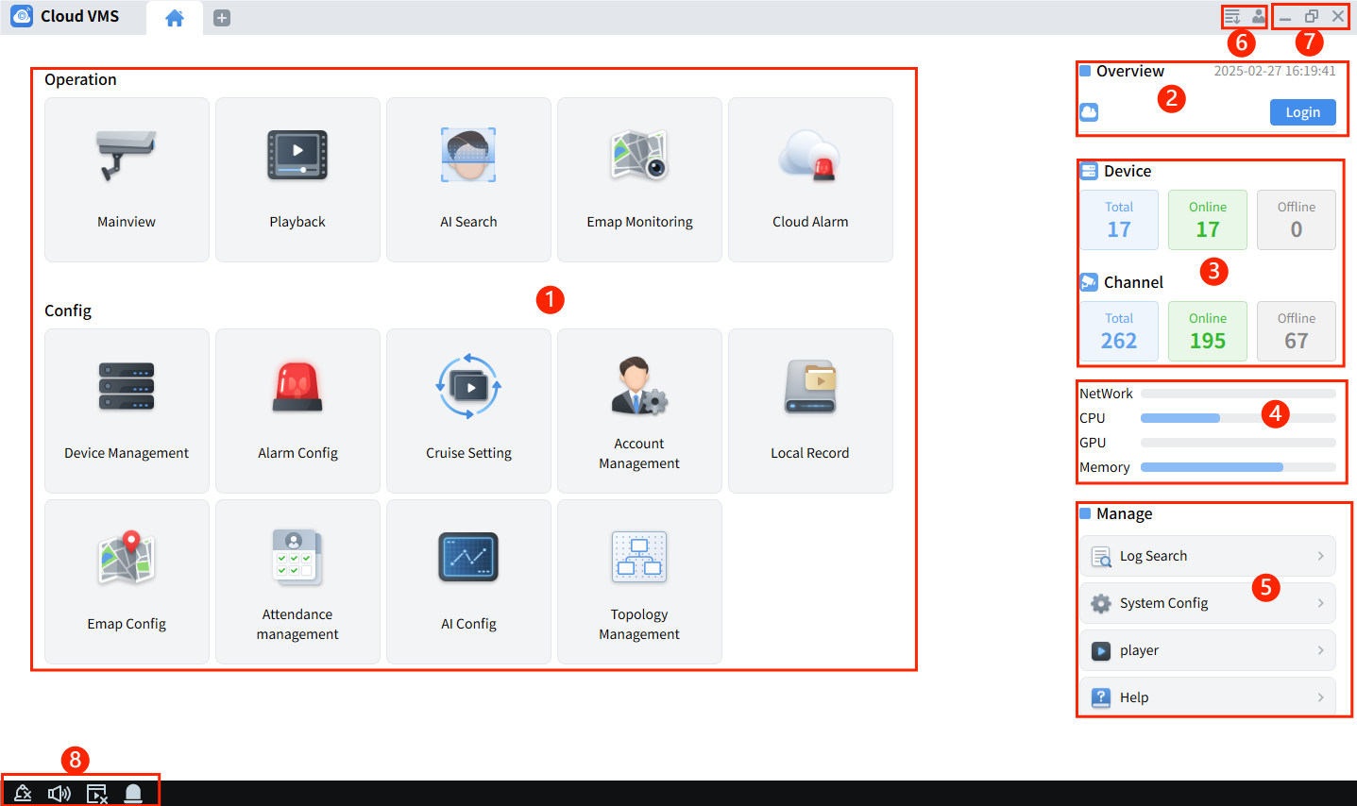
- Function operation area: Displays the main functions supported by the client.
- Cloud account login display: Can import devices under the cloud account in the normal login model.
- Devices statistics: Can display the number of added devices, online devices, and offline devices in real time, the number of total channels, online channels and offline channels.
- PC performance display: Real-time display of the current PC’s network, CPU, GPU and memory usage.
- Can perform log search, system configuration, open the player and view the client version.
- User management: Click, view the video being downloaded and completed.
Clickand select, lock the screen, require the login password to unlock.
Clickand select, display the software name and version number.
Click and select, pop up the login interface of the current user.
- Window management: Click, minimize the software window.
Click, maximize the software window.
Click, restore to the initial software window.
Click, exit the software.
- Event management: click the icon to switch alarm prompt to silent or sound.
click and icon to switch the alarm pop-up box to hide or show.
click icon to clear the alarm information.
click icon to view the alarm information of the device hard disk error. For details, please refer to Chapter 11 Alarm Settings.

Chapter 2 Registration and Login

2.1 Creating administrator account
When logging in to Cloud VMS for the first time, please set the administrator login password and security questions according to the system prompts, the login password you set is used to log in to the system, and the security questions you set can be used to reset the password by answering the questions.
Step 1: Double-click 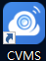, the Initialization screen is displayed, as shown in the following the figure.
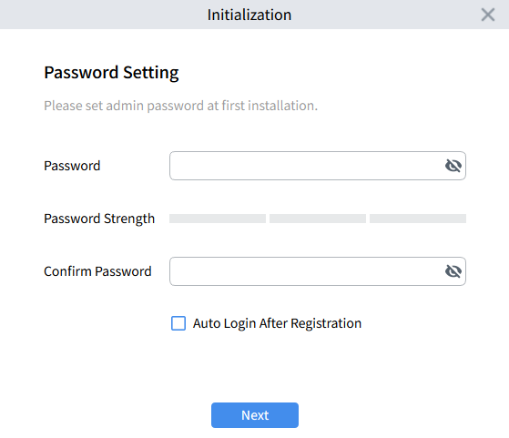
Set the administrator password.
- Password: The password can be set to 8 to32 characters without spaces, and can be composed of uppercase letters, lowercase letters, digits and special characters.
- Password Strength: The color indicates the strength of the password, the colors of the passwords are red, yellow and green, from weak to strong. It is recommended that the password be set to a combination of 3 or more characters.
- Confirm Password: Must be consistent with the password field.
- Auto Login After Registration: If selected, you log in to the system automatically after registration. Otherwise, the system login screen is displayed.
Step 2: Click the“Next”button after setting the password, enter the password protection setting page.
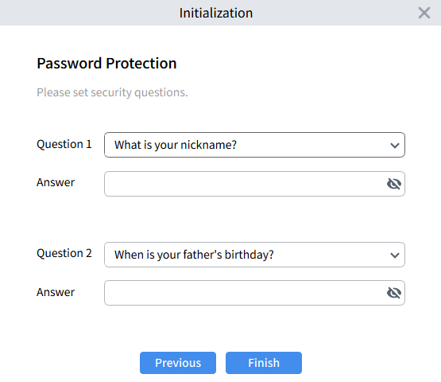
Step 3: Select questions and enter the answer. If you forget your password, you can reset the password by answering the questions.
Step 4: After the setting are completed, click Finish to save the configuration.

2.2 Login into Cloud VMS
After completing the system administrator registration, enter the login screen, supports normal mode and cloud mode, with two login methods to choose from.

2.2.1 Normal Mode
This mode supports the management of all the devices. Enter the system registration password, click Login, and enter the system page
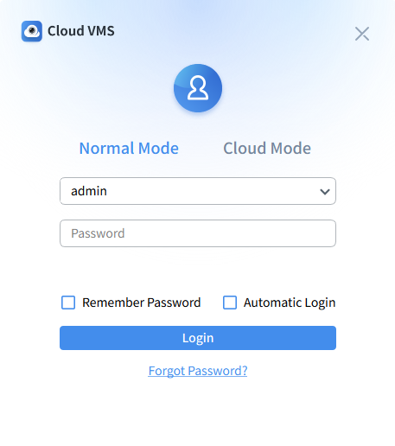
Note: After checking Remember Password, the system will remember the password and you don’t need to enter the password when you log in again. Check Automatic Login, and the system will automatically log in and enter the system when you log out and open it again

2.2.2 Cloud Mode
This mode supports the management of devices with cloud server functions. After registering a cloud account, you can log in using cloud account, devices added under the cloud account can be shared based on the cloud account.
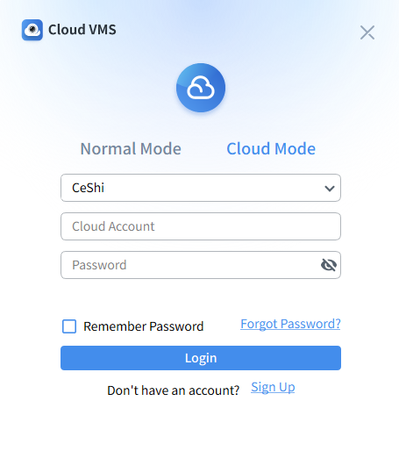
To use cloud mode, you need to register a cloud account. The registration steps through Cloud VMS are as follows.
- Click the Sign Up button on cloud mode login page to enter the registration page, as shown below.
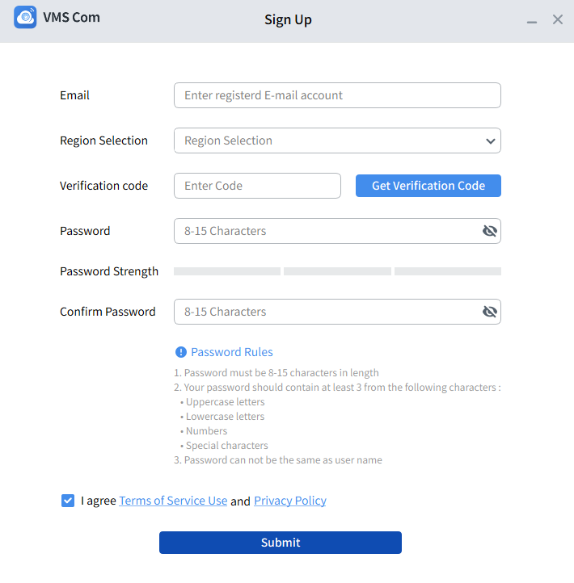
- Enter your email address, select your registration location, enter the verification code you received and set a valid password. Check "I agree Terms of Service Use and Privacy Policy", submit and complete registration. Log in with your registered account and enter the system, as shown below picture.
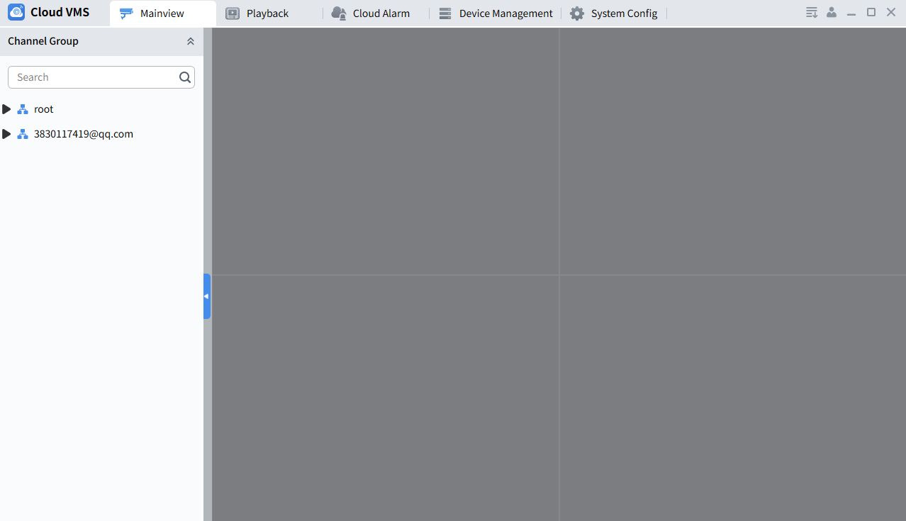
- In cloud mode, Cloud VMS supports the following operations.
Device management:
LAN Search --- Only supports searching and displaying devices that support cloud service functions.
Device Addition --- Supports manual addition in normal/dynamic cloud mode. (Note: When adding in normal mode, the devices will be directly judged. If the device is non-cloud device, it will be recorded in the cloud, If the device is a cloud device, it will be uploaded to the cloud).
Cloud Grouping --- For details, see Chapter 3 3.5 Cloud Grouping Management.
Share Device --- For details, see Chapter 3 3.6 Share Device
Accept Sharing --- For details, see Chapter 3 3.7 Accept Sharing
Preview: Support preview operation of added online devices. (Note: In cloud mode, sidebar alarm, screen patrol, save view and other functions are not supported)
Playback: Support playback operation of added online devices. (Note: In cloud mode, only regular video playback is supported)
Cloud Alarm: Support alarm and system messages query operation of cloud devices. (Note: For details, see Chapter 18 Cloud Alarm)
System Configuration: In cloud mode, you can configure the system language, video file type, video event package size, snapshot and video save path, and disk storage space shortage alarm limit information.

2.3 Resetting the Password
When a user forgets his password, he can reset it by clicking the“Forgot Password” button at the bottom of the login page.
- In local mode, click“Forgot Password”to open the password reset page. After the user passed the question verification, they can reset the password.
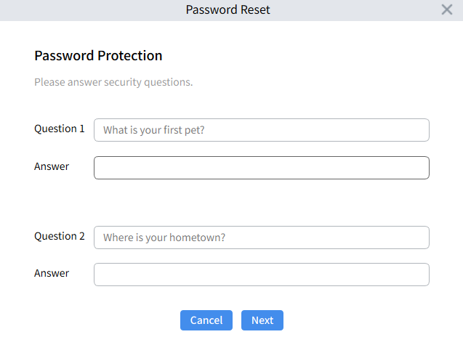
- In cloud mode, click“Forgot Password”to open the password reset page. The user can reset their password by entering the verification code.
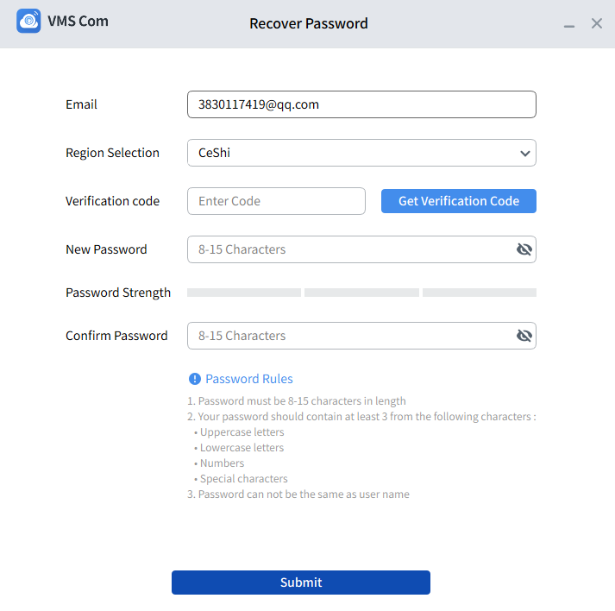

Chapter 3 Device Management
Cloud VMS supports adding devices(such as IPC, NVR, XVR, etc.) individually or in bathes through LAN search and manual methods, and manages for the added devices.

3.1 Device Search
On the Device Management -- Automatic Search page, click the Search button to search and display the devices in the current LAN.

3.1.1 Search by protocol type​
Step 1: On the Devices Management -- Automatic Search page, you can search for devices by selecting the protocol type, as shown in the following figure.
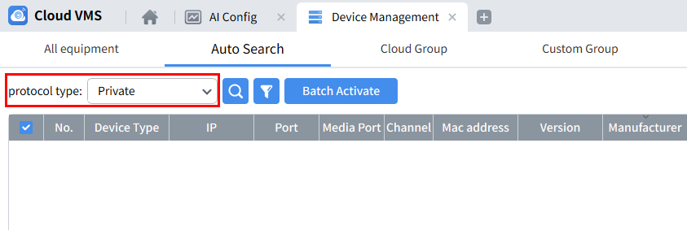
Note: CVMS supports searching for private, Hikvision, Dahua and Onvif protocol types.

3.1.2 Search by network segment
By setting a specified network segment, you can search for devices whose IP addresses are within the set network segment.
Step 1: On the Device Management -- Automatic Search page, click , the system pops up ”Search by segment” interface, fill in the network segment according to actual needs, and click “search” to start searching.
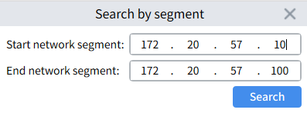

3.2 Activate the device
When the searched device is in an inactive state, you can activate the device, as shown in the following figure.
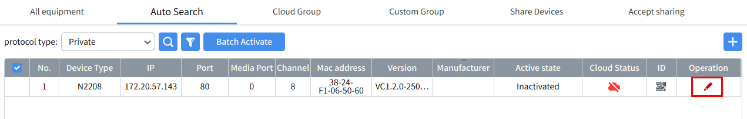
Click button, the activate operation pop-up window pops up, as shown below picture.
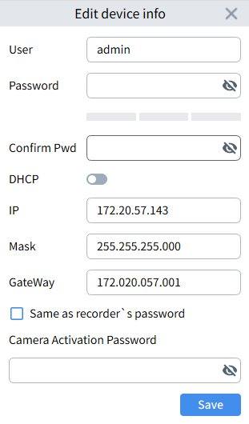
Set a password to complete the activation of the device. You can also set the network parameters of the device during activation. When you need to activate multiple devices, you can select multiple devices and click the “Batch Activate” button at the top of the page to activate multiple devices.
Note: The password must meet the device password rules, after successful activation, the device will be automatically added to Cloud VMS.

3.3Add Device​​

3.3.1 Search Add
On the Device Management -- Automatic Search page, click Search button to search for LAN devices. Select one or more devices based on the search results. Click the Add button and enter User Name and Password of the device in the pop-up menu to add it, as shown in the figure.
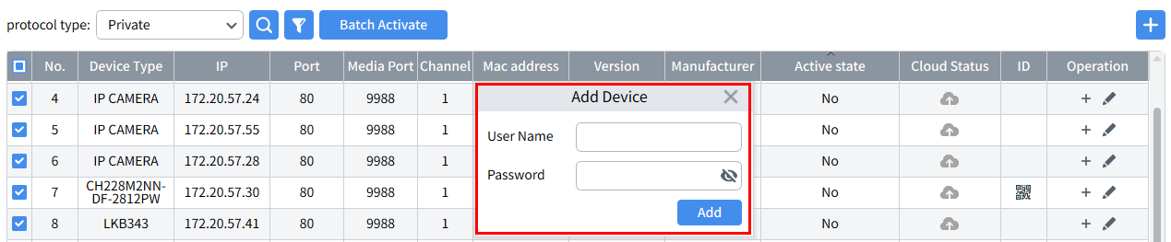

3.3.2 Manual Addition
On the Device Management -- All Devices page, click the Add button. In the pop-up page, you can select Normal Mode or Dynamic cloud according to your needs.
- Add in Normal Mode (support adding devices by IP, P2P ID, DDNS)
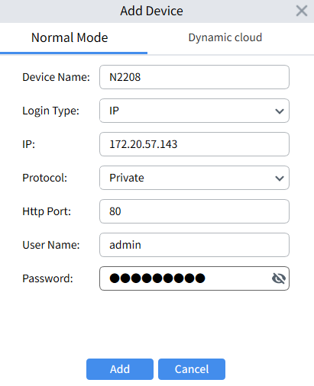
- Add in Dynamic cloud (supports adding devices through Cloud ID, and the dynamic code needs to be obtained from the device side)
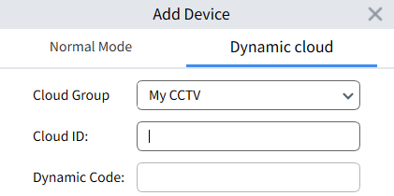
On the device management page, you can perform the following operations for the added devices:
- : Click this icon to enter the "Modify Device" interface, which supports modifying device information, including device name, login type, IP/P2P/domain name, protocol, port, user name and password.
- : Click this icon to enter the "Remote Configuration" page, where you can configure the device's parameters remotely.
- : Manually log in or out of the device, and manually log in and out of the added device.
- : Select the device and Click delete it.
- : Export/import device parameter operations.
- : Select the device and click the button to manually check whether there is a firmware version available for upgrade. (This button will only be displayed for devices that support online upgrades)
- Connection Status:
Green: Device connected successfully
Red: Not activated, need to set initial password
Gray: Device connection failed
- : Device P2P, Click view the device's P2P (Note: only supports devices with private protocols)
- : Search box: Enter the device name in the input box to quickly find the device
- : Device upgrade, select the upgrade file, you can upgrade the device (Note: support up to 10 devices to upgrade at the same time)
- : Select the online device, click the cloud button to select the cloud group, and you can upload the device to the cloud (Note: In Normal Mode, you need to log in to the cloud account to upload the device to the cloud, for devices that do not support cloud service functions, the cloud status is recorded in the cloud after the cloud is uploaded)
- : You can export or import the devices added on CVMS.

3.4 Custom Group Management​
In the Device Management - Custom Group interface, you can create a new custom group and assign the channels of the added devices to the new group to facilitate centralized management of specific device channels.
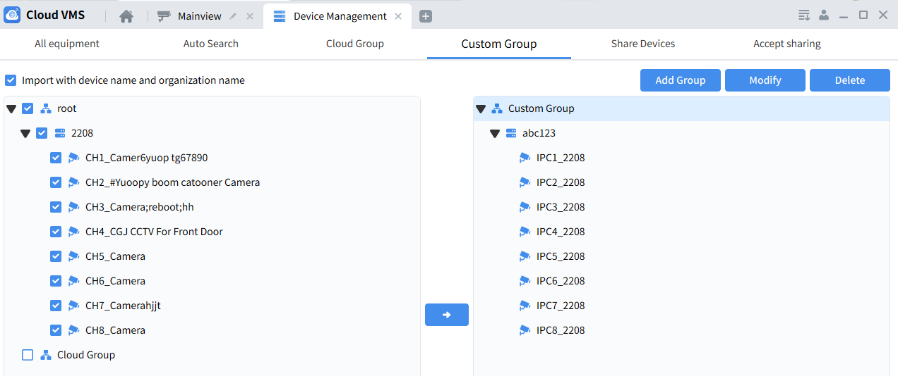
Operation steps:
1. Click Add Group button, set the group name in the pop-up menu, and create a group.
2. Select the device channel in the list on the left, click button, Import into new group.
Note: When "Import device name and organization name" is not selected for import, the channels will be imported into the custom group, not into the organization.

3.5 Cloud Group Management
In the Device Management - Cloud Group page, you can create, share, and delete groups.
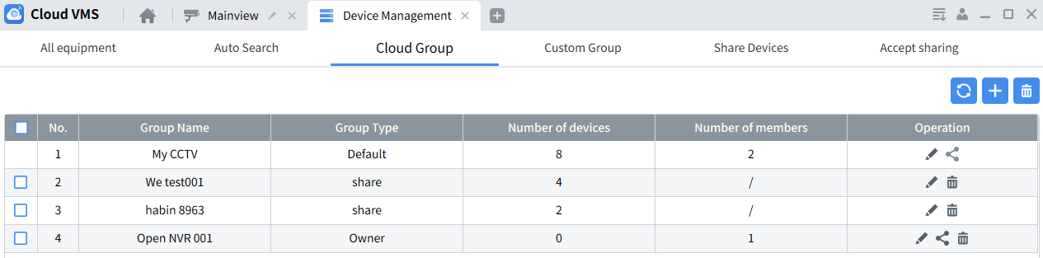

On the Cloud Group page, there are three types of groups:
- Default group: cannot be deleted, group name can be edited, Devices can be moved from other groups, and groups can be shared with other accounts
- Custom Group: If a device exists, it cannot be deleted. You can edit the group name, move devices from other groups, and remove devices in this group.
- Share Devices: Shares from other accounts can be deleted and group names can be edited
Select a group that supports the sharing function, click the share button, enter the sharing settings page, click , enter the account to be shared in the pop-up menu, and start group sharing.
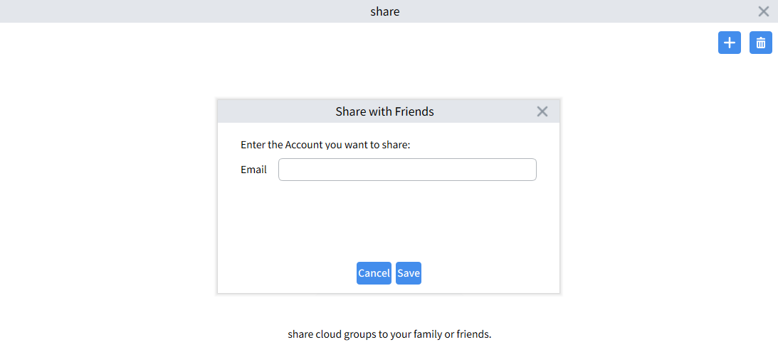
For the shared account, you can modify the account nickname and delete the account.
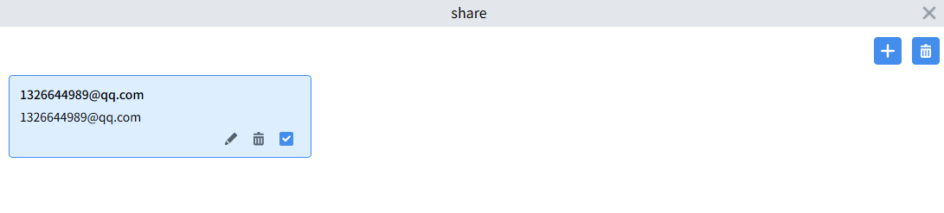

Note:
1. The sharing group function only supports sharing the groups that exist under the current cloud account (groups shared from other accounts cannot be shared)
2. When deleting a shared account, the groups and devices received by the shared account will be deleted simultaneously.

3.6 Share Devices
In the Device Management - Share Devices page, you can share and delete devices.
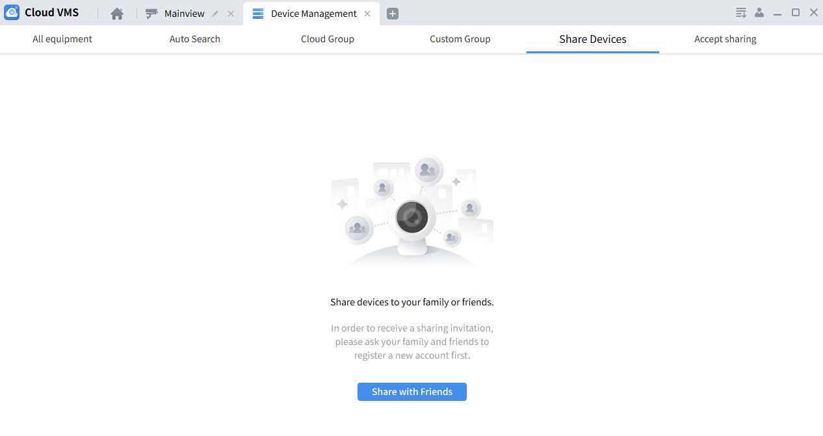
On the Share Devices page, click, enter Share with Friends settings page, select the device and channel to be shared, and set the operational permissions to share.
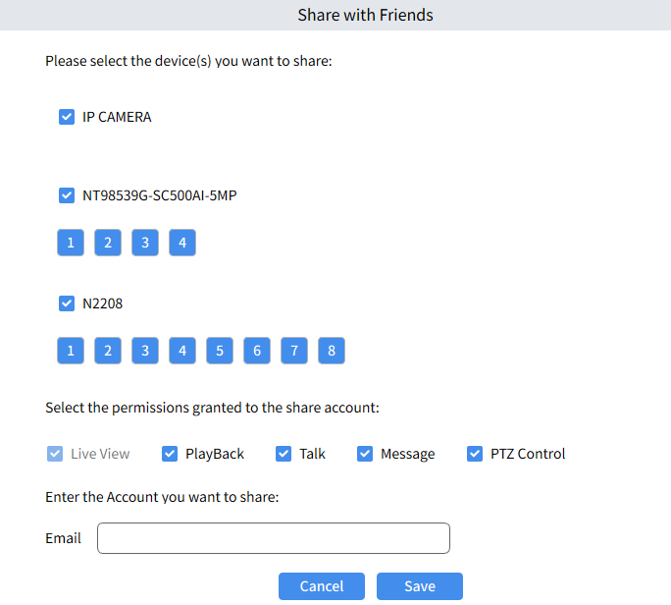
For shared accounts, you can modify nicknames, modify permissions, and delete accounts.
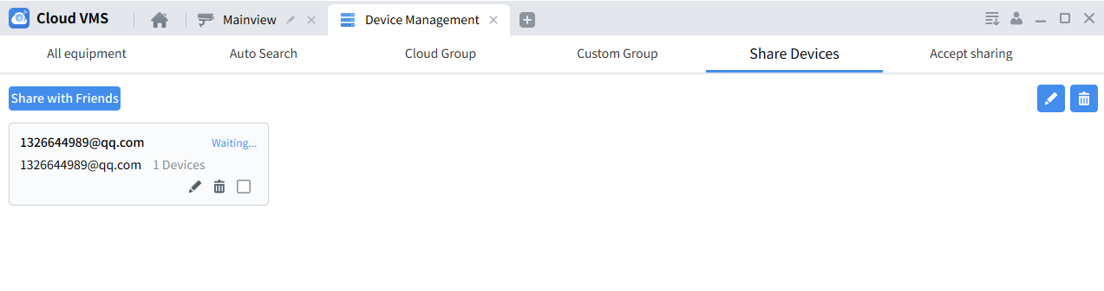
Note:
1. The device sharing function only supports sharing devices that have been uploaded to the cloud under the current cloud account.
2. When deleting the shared account, the devices received by the shared account will be deleted simultaneously.

3.7 Accept sharing
On the Device Management - Accept Sharing page, you can accept or reject groups or devices shared from other accounts.
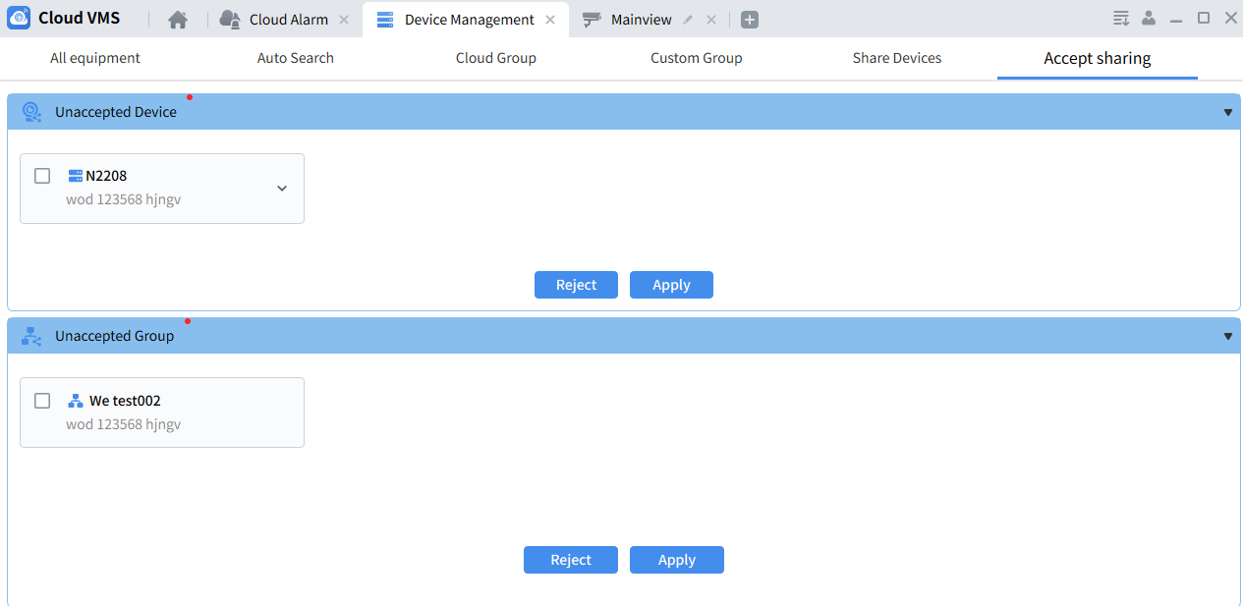
Note: For the device receives invitations you have received, you can select all or part of the channels of the device to receive. For the received devices, you can delete the channels and devices, and modify the nickname of the sharing account.

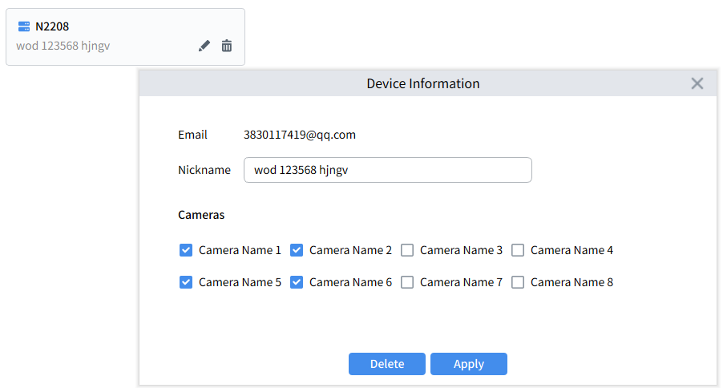

Chapter 4 Preview

4.1 Interface Introduction
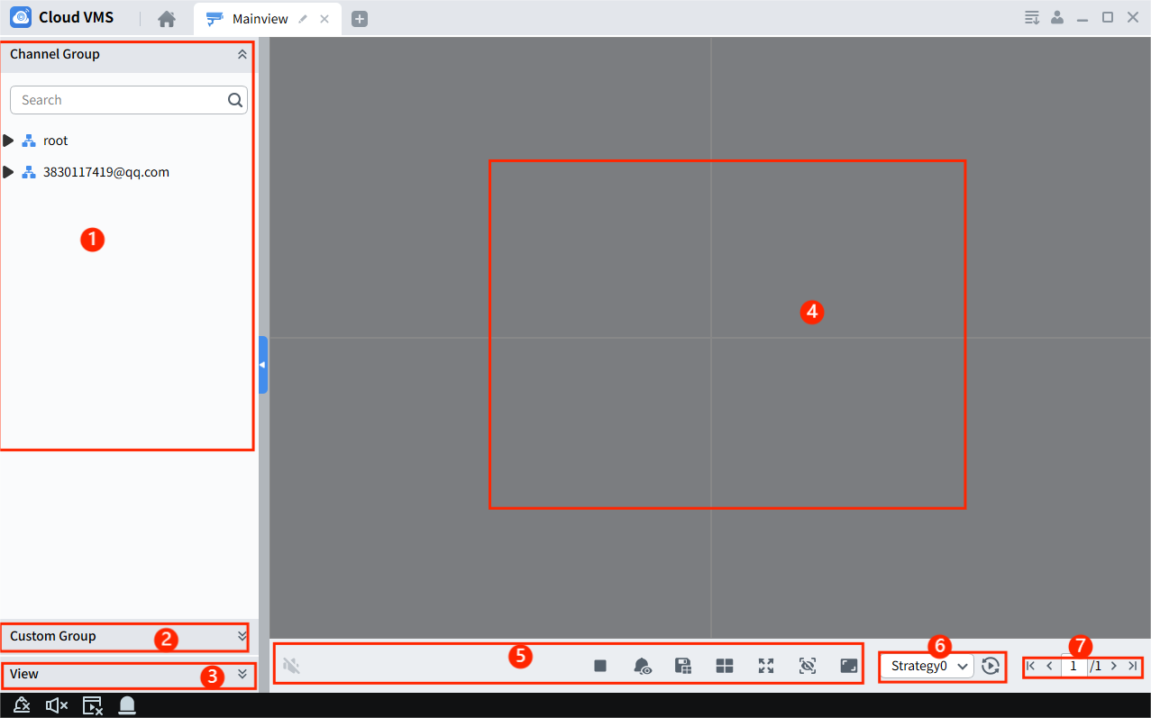
Select "Mainview" in the "Main Menu" and the system will enter the preview interface. The function introduction is as follows.
- root group: This group displays devices added by IP, P2P ID, and DDNS.
Account group: This group displays devices bound to the current cloud account.
- Custom Group: Click Custom Group to expand the custom group, which supports previewing the devices added to the group. For specific device adding methods, see Section 3.4.
- View: To preview multiple device channels at the same time, click the button belowto save the current preview window channel to the view so that it can be directly called next time.
- Preview window area: Select a device or channel and drag it to this area to preview and control the channel.
- Preview control area:
: Controlling Audio
: Switching between main and sub streams
: Stop previewing in all windows
: Turn on/off warning light
: Turn on/off warm light
: Turn on/off the alarm
: Turn on/off privacy mode
: Remove the alarm and video labels from the preview screen
: Click enter the preview layout page, you can customize the preview layout, up to 5
: Full screen display
: Open/close the sidebar alarm box, displaying the smart alarms generated by the devices added to Cloud VMS
: Click enter the manual alarm page and turn on/off the manual alarm
: Save Preview
: Click enter the screen display ratio setting page, you can set 4 screen display ratios: stretch, 16:9, 4:3, and original ratio
- If a channel patrol plan has been configured, you can select a plan in this area to start patrolling.
- If the preview channel is not fully displayed in the current window layout, you can switch to different preview pages here.

4.2 Live Preview
View the camera image in real time, and support local recording, screenshots, voice intercom, electronic zoom and other operations.
1.Preview operation
In the preview state, the operations that can be performed at the bottom of the channel and in the right-click menu are as follows:
Manual recording: You can manually record the preview image and save it to your local computer
Manual capture: You can capture the preview screen and save the image to the local computer
Electronic zoom: Click the left mouse button to zoom in on the selected area in the preview screen
Channel intercom: Click intercom with the front-end camera (the camera must support the intercom function)
Device intercom: Click intercom with the device (the device must support the intercom function)
Tags: Add tags to mark specific events for easy retrieval
Instant playback: Default fast playback of the current time before 10 minutes of recording, the duration can be modified in the system settings
PTZ control: Click open the PTZ operation page, where you can adjust the viewing angle of the device.
2.Video Settings: Select the preview channel and right-clickto open the video parameter setting menu. This menu supports setting the channel name, date and time, and image color parameters.
3.Fisheye Mode: Connect to the channel of the fisheye camera and select the corresponding view according to the installation method. In the preview or playback window, click “” or right-click and selectto open the fisheye menu, as shown in the figure.
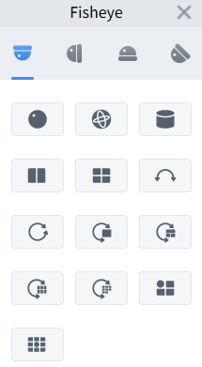
Select the corresponding mode according to the actual installation of the camera. In the selected mode, you can operate different views and preview from multiple angles.
Ceiling/wall/ground mounting: Original image, that is, the original image without correction.
Ceiling mounting: that is independent sub-screens, the sub-screens support zoom and move operations.
Ceiling/ground mounting:
VR mode, double-Click enter, the screen supports zoom and move operations.
Cylindrical mode, drag the mouse up and down to switch the cylindrical screen to flat display, the screen supports up, down, left, and right drag operations
4 independent sub-screens, the sub-screens support zoom and move operations.
2P: 2 associated 180°rectangular expansion screens, the two sub-windows form a 360°panorama at any time, also known as "double panorama", the two rectangular expansion screens both support left and right movement of the starting point operation, and are linked to each other.
1P: 360°rectangular unfolded panorama, rectangular unfolded panorama supports mobile operation.
: 1P+1, 360°rectangular panorama + 1 independent sub-screen, the sub-screen and the sub-frame in the rectangular panorama support zoom and move operations. The rectangular panorama does not support zoom and move operations.
: 1P+3, 360°rectangular panorama + 3 independent sub-screens, the sub-screens and the sub-frames in the rectangular panorama support zoom and move operations. The rectangular panorama does not support zoom and move operations.
: 1P+6, 360°rectangular panorama + 6 independent sub-screens, the sub-screens and the sub-frames in the rectangular panorama support zoom and move operations. The rectangular panorama does not support zoom and move operations.
: 1P+8, 360°rectangular panorama + 8 independent sub-screens, the sub-screens and the sub-frames in the rectangular panorama support zoom and move operations. The rectangular panorama does not support zoom and move operations.
Ceiling/ground mounting:
: 1+3, original image + 3 independent sub-pictures, the sub-pictures and sub-frames in the original image support zoom and move operations. The original image supports zoom operations.
: 1+8, original image + 8 independent sub-pictures, the sub-pictures and sub-frames in the original image support zoom and move operations. The original image supports zoom operations.
Wall mounting:
VR mode, double-Click enter, the screen supports zoom and movement operations.
1P, unfold the panorama from left to right 360°rectangle and change the vertical viewing angle. Does not support zoom and move operations.
4, 4 independent sub-screens, the sub-screens support zoom and move operations.
1P+3, 360°rectangular panorama + 3 independent sub-screens, the sub-screens and sub-frames in the rectangular panorama support zoom and move operations. The rectangular panorama changes the vertical viewing angle and does not support zoom and move operations.
1P+8, 360° rectangular panorama + 8 independent sub-screens, the sub-screens and sub-frames in the rectangular panorama support zoom and move operations. The rectangular panorama changes the vertical viewing angle and does not support zoom and move operations.
1+3, original image + 3 independent sub-pictures, the sub-pictures and sub-frames in the original image support zoom and move operations. The original image supports zoom and move operations.
1+8, original image + 8 independent sub-pictures, the sub-pictures and sub-frames in the original image support zoom and move operations. The original image supports zoom and move operations.

4.3 View Settings​
On the preview interface, click to enter the view page, where you can set and view custom views.
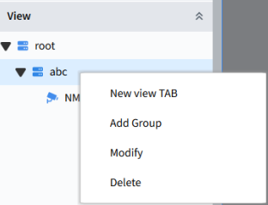
1.Add Group:
Right-click on the root of the view tab to open the right-click menu options. You can only add groups on the root. Select "Add Group" as shown in the figure.
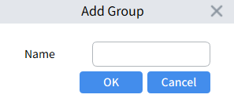
Edit the custom name and click OK to create the group.
2.Add Plan:
Right-click on the custom added group and select "New view TAB" to open the plan settings interface as shown in the figure.
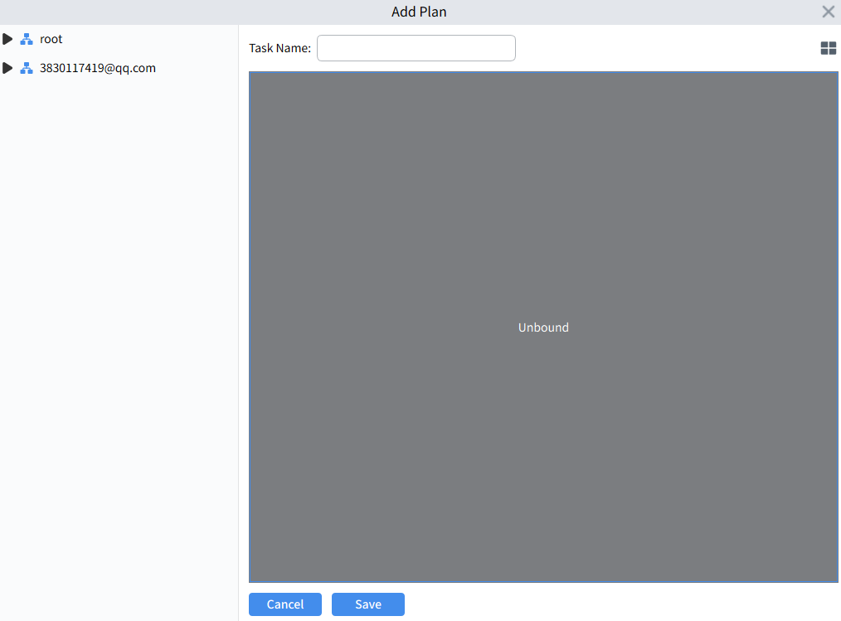
In the upper right corner, clickto select the required split screen, select the channel from the device list on the left, drag it into the view window and save it.
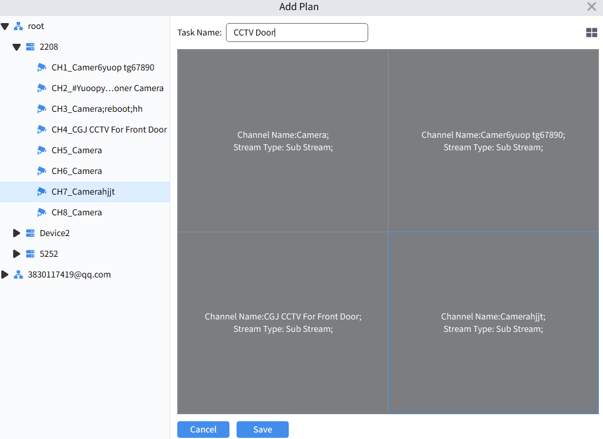
3.Modify or delete view tabs:
In the view tab directory, select "Modify" to modify the view tab or group.
In the view tab directory, select "delete" to delete the view tab or group.

4.Switch view tab preview
After adding a few more view tabs, double-click the view tab to quickly switch the preview view.

4.4 PTZ Control
In the preview interface, clickto enter the PTZ control panel.Depending on the connected camera, the functions supported by the PTZ may vary. Take the PTZ camera as an example:
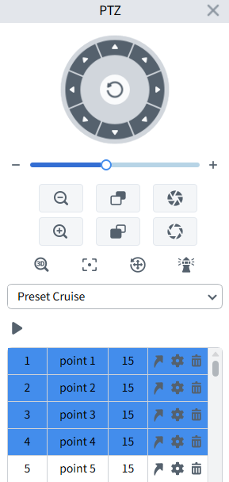
1.3D Position: Turn on/off the 3D positioning function. Clicking ”” means turning on 3D positioning, after turning it on, the button changes to “” When you click the button again, 3D positioning will stop. When the system turns on the 3D positioning function, you can perform the following operations.
Use the left mouse button to click somewhere on the preview screen, and the network high-speed dome will move the corresponding point to the center of the video.
Press and hold the left button to pull out a rectangular area to the lower right (upper), and the network high-speed dome will move its center to the center of the video and zoom in.
Press and hold the left button to pull out a rectangular area to the upper left (lower), and the network high-speed dome will move its center to the center of the video and zoom out.
2. PTZ Reset: One-key reset. Click this button and the network high-speed dome will clear the preset points and cruise path.
3. One-key watch, Click execute one-key watch once, this function depends on the model
4. When the network high-speed dome turns on the watch function and no control signal arrives after the set watch waiting time, the network high-speed dome will automatically execute the preset action.
Select the cruise mode as Watch Mode.
Set the time interval: When manually rotating the network high-speed dome, wait for 20 seconds to resume the watch action, and you can choose 15-240 seconds.
Select the watch mode: there are default cruise, preset point, linear scan, track cruise and pattern scan options.
Note: Only one watch point can exist at the same time.
Default cruise: Click the call cruise button, and the device will perform an uninterrupted 360° uniform counterclockwise rotation.
The save button allows the network high-speed ball to save the set parameters without turning on the watch function. Turning on the cruise button can save the set parameters and turn on the watch function.
The watch mode is shown in the below picture.
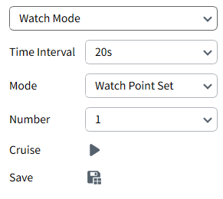
5. Linear Scan: Select the cruise mode as Line Scan, clickto record the current position of the device as the starting position, rotate the device, and clickthe end button, and record the current position of the device as the ending position. Click the Save button to save the three cruise speeds of high, medium or low. Click the Cruise button, and the device will cruise at a constant speed between two points. The Linear Scan page is shown in the below picture.
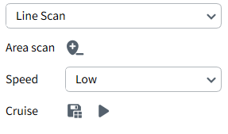
6.Track cruise: Cruise according to the set track. You can set 4 tracks at the same time. Each track can select 32 preset points, and the cruise interval time for each preset point can be set.
Select the cruise mode as Tour
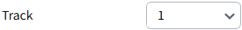 Select the track to add a preset point,
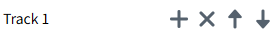 Add and delete preset points to each track, and use the up and down buttons to move the order of the preset points. Select the speed and time interval for switching between different preset points during cruising, click the Save button, and the device will save the parameters without turning on the cruise. Click the Cruise button, and the device will save the parameters and cruise in the order of the added preset positions. The preset point cruise page is shown below:
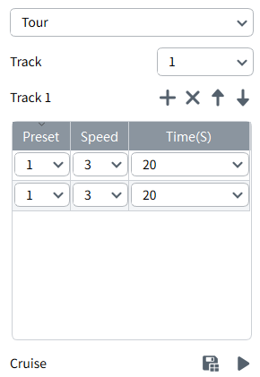
7．Pattern scanning refers to scanning according to a preset path, recording the horizontal and vertical movements of the network high-speed dome, zoom operation and other actions. After recording and saving, the user can directly call the pattern scanning route. The network high-speed dome supports setting 4 pattern scanning paths, numbered 1 to 4. The network high-speed dome provides a save function for each pattern scanning path.
Select the cruise mode as Pattern Scan
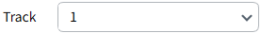Select a path,
Click start recording, perform any PTZ operation on the device, and Click stop recording,
After recording is completed, Click call the cruise, and the device will cruise according to the recorded content.
After recording is completed, click the delete button, and the device will delete the pattern scanning path with the corresponding number. The pattern scanning page is shown in the below picture.
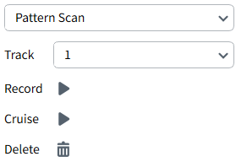

4.5 AI Alarm Sidebar Push Image
Clickthe smart alarm display button, and the alarm push of the added smart device will be displayed on the right side of the preview area.
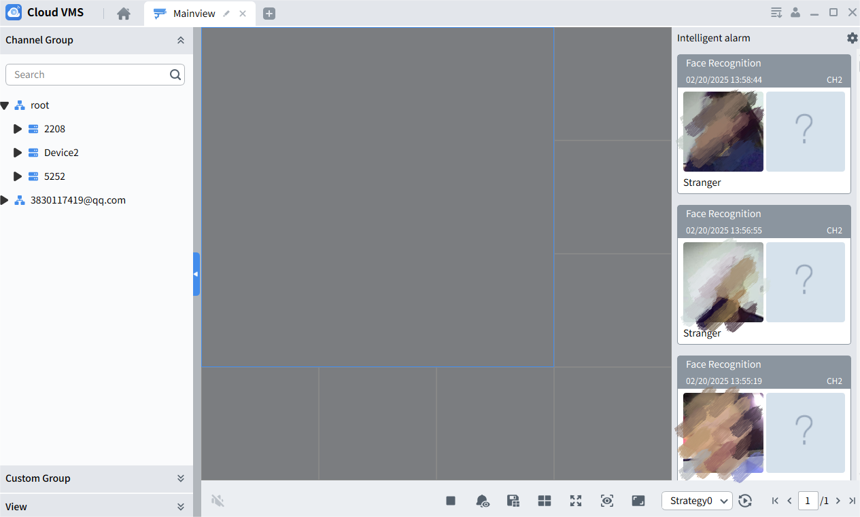
Select the alarm event in the alarm push bar and right-Click view the event information and playback the event-related video.
Playback: Open the playback window to playback the alarm video.
Detail Information: As shown in the figure.
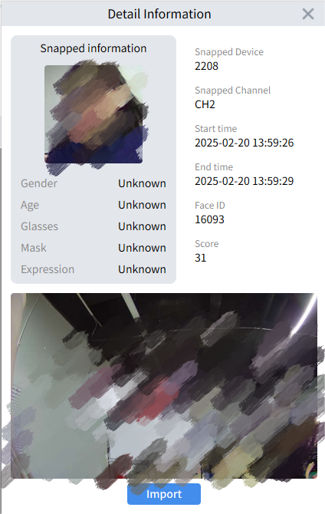
Snapped Device: Capture device
Snapped Channel: Capture channel
Start time: Alarm start time
End time: Alarm end time
If the channel opens the face attribute, the captured image information will include gender, age, whether wearing glasses, whether wearing a mask and expression information. The captured image shows unmatched, which means there is no comparison image.
Select the face image and right-Click add the face image to the face library.
When there are comparison images in the group, as shown in the figure.
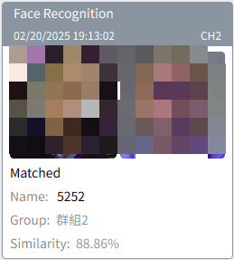
Displays the group to which the matched face belongs ”Similarity”, right-click the menu to view details and edit face information.

Chapter 5 Cruise Setting
By configuring the patrol plan, the preview window patrol function can be realized.

5.1 Configure Patrol Plan
Step 1: Click "Cruise Setting" in the "Main Menu" to enter the cruise setting interface, as shown in the figure.
By default, the system will create a patrol plan named "Strategy0". If you need to modify the patrol plan name, clickto change the plan name.
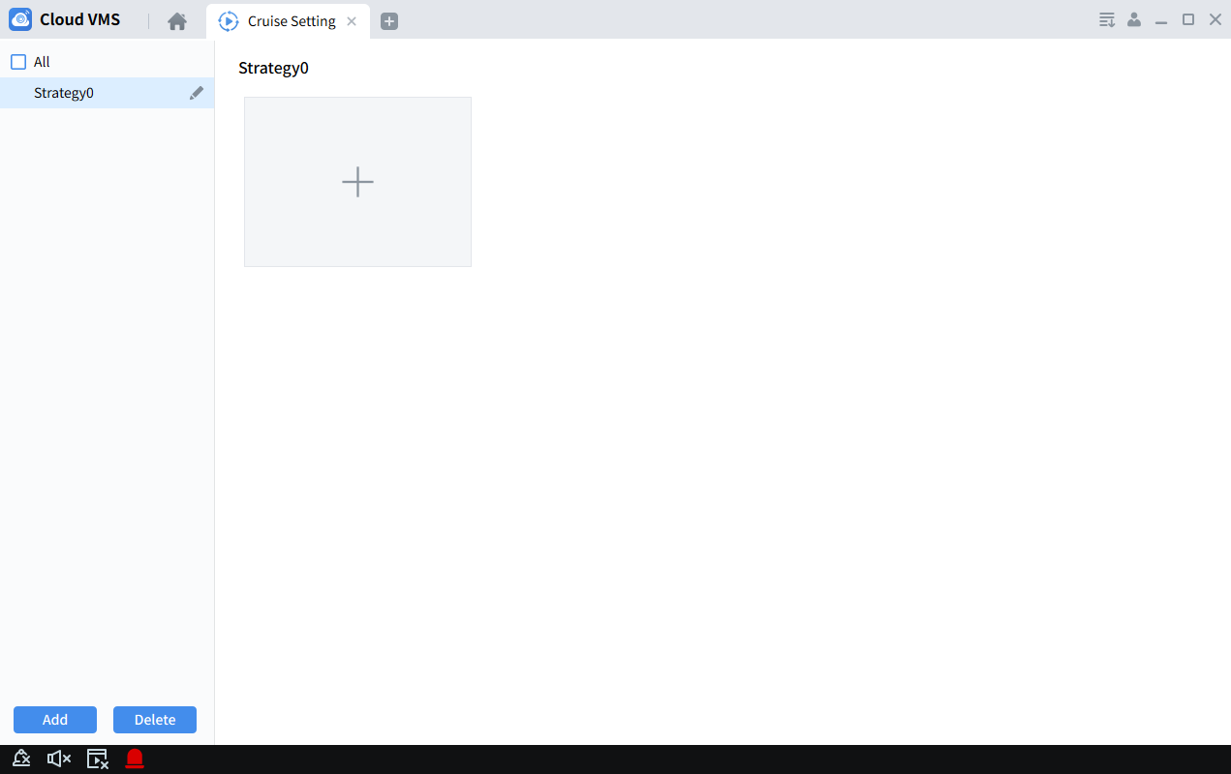
Step 2: Configure the patrol plan ( a patrol plan can set up to 16 preview layouts )
(1) Click to open the “Add Task” interface
(2) Set the "Task Name" and "Task Time", and set the number of preview windows according to actual needs .
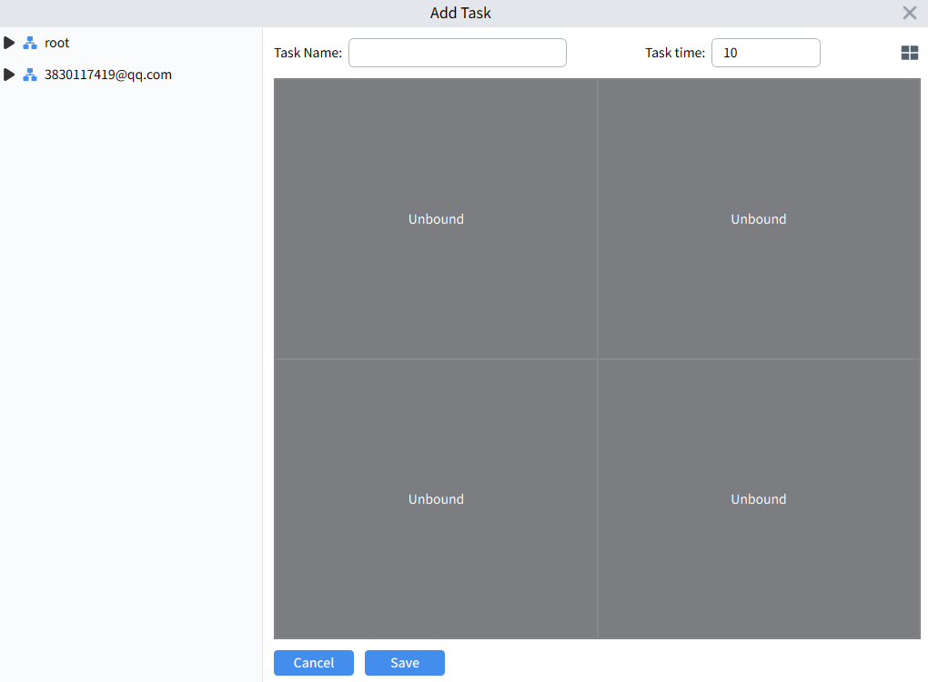
(3) Drag the channels of the device into the video window in the required order, as shown in the figure.
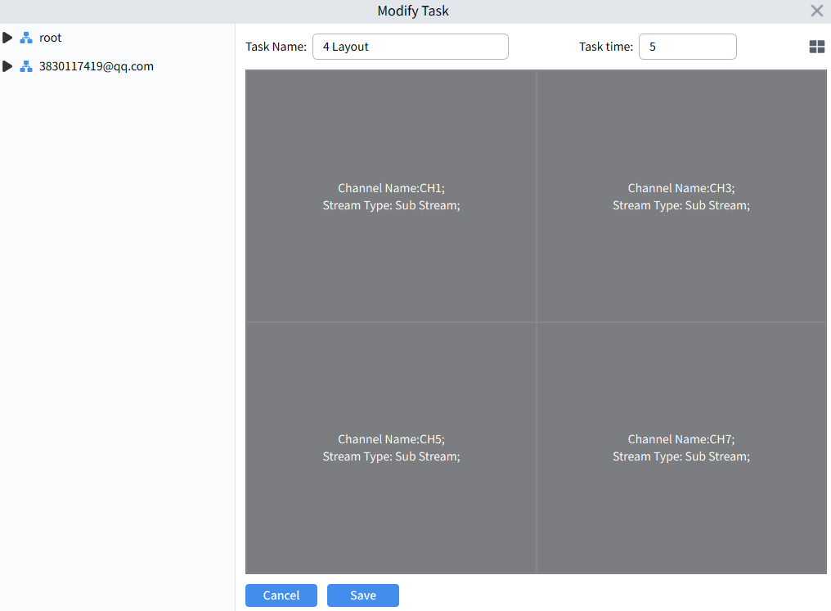
( 4 ) Click "Save" to complete the patrol plan setting, as shown in the figure.
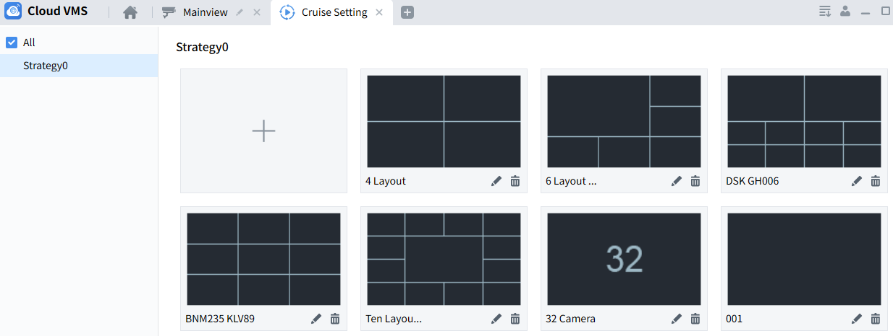

5.2 Start PTZ
Step 1: Select "Main Window" in the "Main Menu" to enter the preview interface.
Step 2: Select a patrol plan at the bottom of the interface, such as 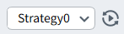
Step 3: Clickto start patrol.

Chapter 6 Playback

6.1 Playback Introduction
Select "Playback" in the "Main Menu" and the system will enter the playback interface, which supports playback and export of device videos and device pictures, as shown in the figure.
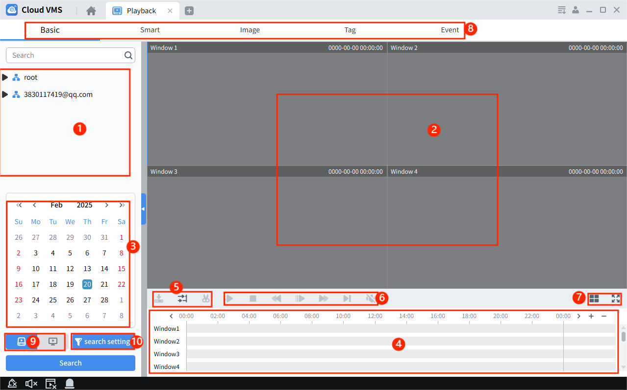
The interface functions are introduced as follows.
1. Playback channel: Check the channel you want to play back, and click Search to search for the corresponding channel video playback.
2. Playback window: video playback display area.
Snapshot: Select the playback window, click or right-click to capture a single picture,
Electronic zoom: Select the video window with video recording turned on and click ,
Stop playback: Select the video window that has been opened for playback, click or right-Click select
Recording: Select the video window that has been opened for playback, click or right-Click select
Enable fisheye mode: Select a video window with playback enabled and click or right-Click select (only available on devices that support fisheye mode.)
Full screen display: Click or right-Click select
Add tags: Click to add tags in the playback
Screenshot: Click on the screenshot , the mouse will turn into a screenshot icon , and click the left button of the mouse in the play box to drag the screenshot.
3. Query time: Set the device video query time.
4. Time progress box: : The precision of the playback progress bar becomes higher. : The precision of the playback progress bar becomes lower. : You can move the progress bar display area.
5. Download, synchronize and cut.
Download, cut or export the recording as needed.
Download device video: refer to Session 7.3 Export device video,
Cut device video: Drag the cutting start point on the progress bar and select the video.
Synchronous playback: Select multiple channels, click the synchronous playback button, and then click Play, and all channels can be played back synchronously.
6. Playback Control Bar
Synchronous playback, when there are multiple channels for playback, click this button and then click Play to play all channels simultaneously.
Start playback
Reverse playback
Pause playback
Stop playback
Single frame forward playback
Fast forward playback
Turn on/off the sound
Enter fisheye mode to play
Slow playback video
7. Window Control:
Select the required video window display mode and number
Video window full screen display mode
8. Playback Type
9. Playback mode: You can choose between device recording and local recording.
10. Search settings: Click to select stream and alarm type for search

6.2 Playback Device Video
Prerequisites:
The selected channel device has recordings.
Steps:
Step 1: In the "Playback " interface, select
Step 2 : Select the device channel in "Device Group".
Step 3 : Set the video query conditions.
1. Select the recording type and bitrate, and select the date and time.
2. Click "Search" and the system will display the recording information in the time progress box.
Step 4: Select the window with the video, click, and the video will start playing, as shown in the figure.
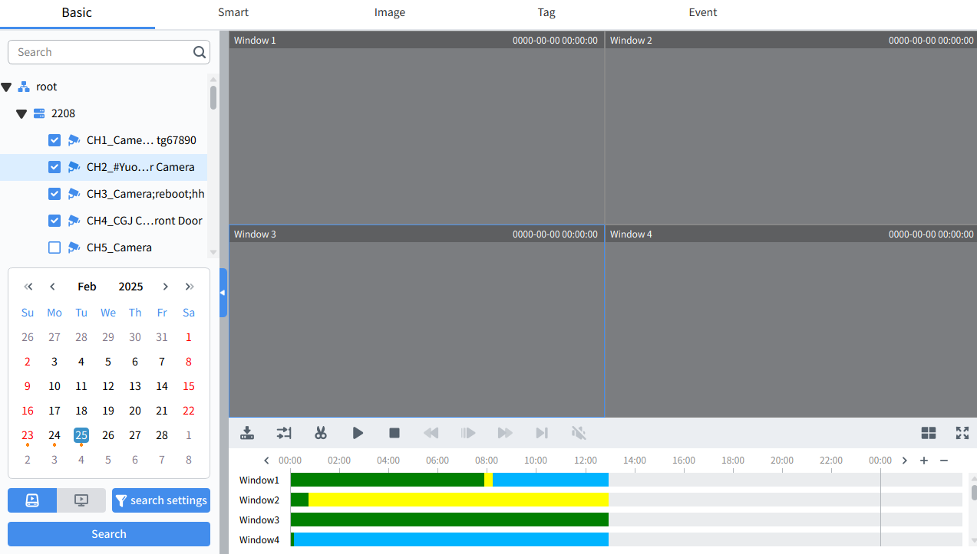

6.3 Download device video
Prerequisites:
There is video recording on the device channel.
(1) Custom cut and download:
Step 1: In the "Playback " interface, select
Step 2 : Select the device channel in "Device Group".
Step 3 : Set the video query conditions.
1. Select the recording type and bit rate, and set the time.
2. Click "Search" to display the recording information in the time progress box.
Step 4 : Click to select a video in the video progress bar, then click , and a menu will pop up, as shown in the figure.
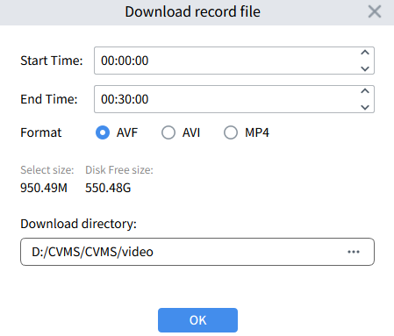
Step 5 : Select the export video format, save path and confirm , add the video to download , click to open the download menu, and check the " download progress". as shown below picture.
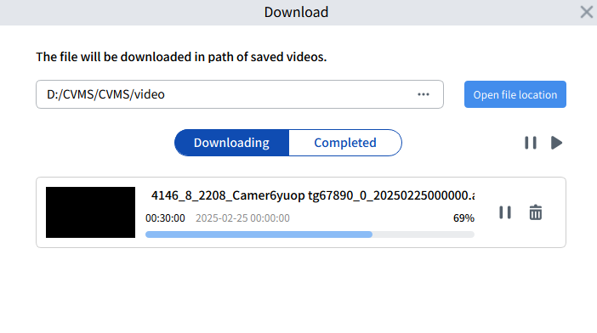
(2) Download by device file time:
Step 1: In the "Playback " interface, select
Step 2 : Select the device channel in "Device Group".
Step 3 : Set the video query conditions.
1. Select the recording type and bit rate, and set the time.
2. Click "Search" to display the recording information in the time progress box.
Step 4 : Select the window where the video exists, click on the playback control toolbar , and all the video clips of the channel on that day will pop up, as shown in the figure.
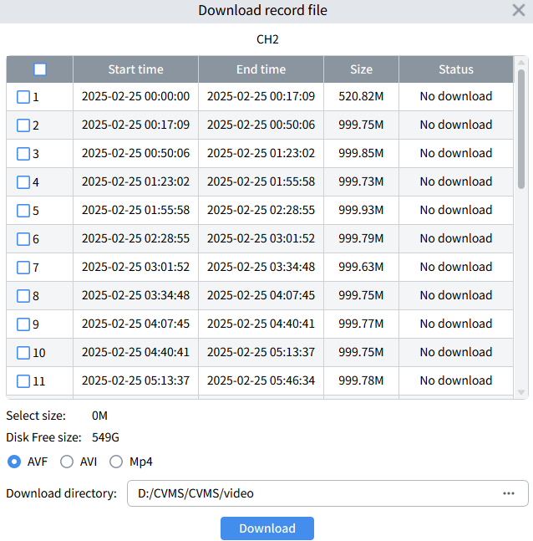
Step 5: Check the time period you need to download, select the export video format, save path and confirm , add the video to the download , click to open the download menu, and view the "download progress". as shown below picture.
Note: When you choose AVF format for downloading, the video can be encrypted. When playing it with a dedicated player, you need to enter the correct password to play it.

6.4 Smart Search Playback
Select "Playback" in the "Main Menu" and the system will enter the Smart playback interface. Select the channel to search and play the video. The area with video on the timeline will appear blue. During playback, click the left mouse button on the playback screen and drag the frame to select the area of interest, click to search for motion videos in the selected area, click to delete the selected area.
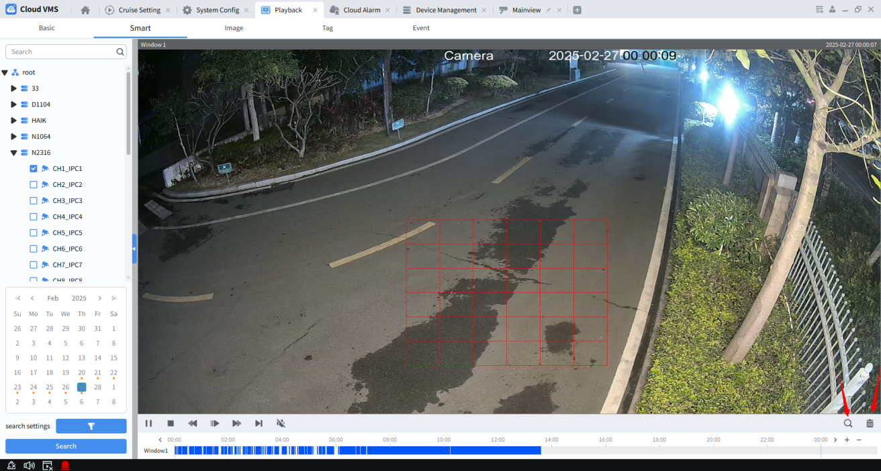
Note: The smart playback function can only operate one channel at a time

6.5 Image Search And Backup
Prerequisites:
The selected device channel has screenshots on the device side and locally.
Steps:
Step 1: Select the Image page in the " Playback " interface
Step 2 : Select the device channel in "Device Group"
Step 3 : Set the image query conditions in .
1. Select the search location (device or local), image type and set time.
2. Click "Search", as shown in the figure.
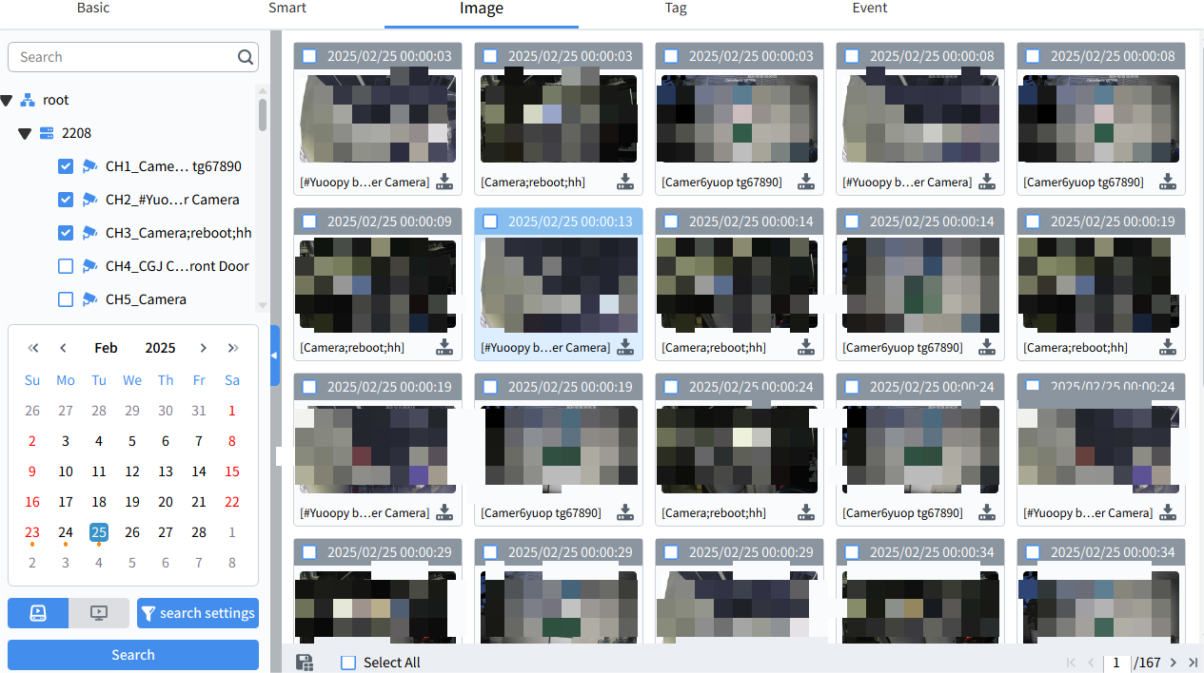
Select to search for screenshots stored on the device, and select to search for screenshots stored locally.
In the image display window, click the lower right corner of the searched image to save the searched image to the specified directory.
Select or batch select the searched pictures, and click to save the pictures in batches to the storage directory.
Note:
1. Images found through local search can be deleted.
2. The image save path can be set in "System Config" in the main menu.

6.6 Tag Playback​​
Prerequisites:
During preview or playback, the time points of interest are marked.
Step 1: Select the tab in the "Playback" interface
Step 2: Select the device channel in "Device Group".
Step 3: Set the search time and keyword (If the keyword is empty, it means search all) and click Search. The search results will be displayed in the right window , as shown below picture.
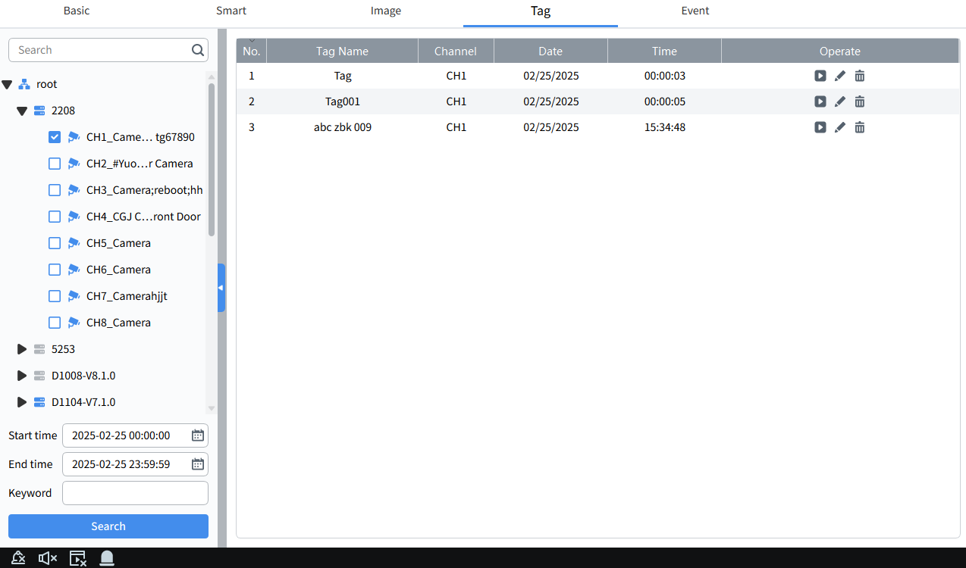
Select any tag event found, click to playback the tag event , click to modify the tag name , and click to delete the tag.

6.7 Event Playback
Step 1: Select event playback in the " Playback " interface
Step 2: Select the device channel in "Device Group"
Step 3: Set the start time and end time, search the location (device or local), click Search, and the search results are as shown below picture.
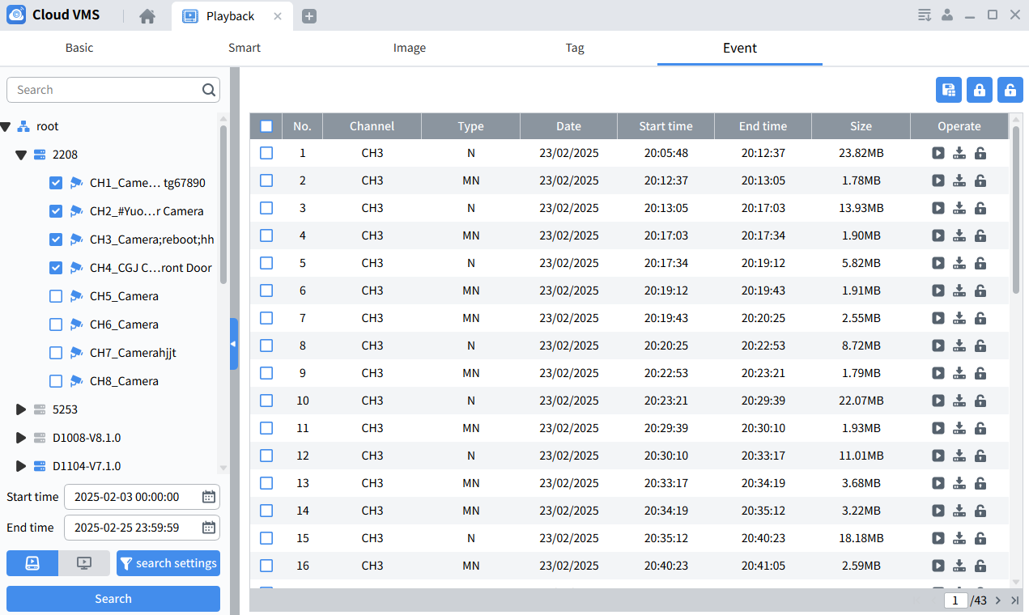

Select to search for events stored on the device, select to search for events stored locally.
Select any searched event and click to playback the event, click to lock the recorded event so that it will not be overwritten, click / to download the selected recorded file.
Note:
1. Events found in local search can be deleted.
2. The event saving path can be set in "System Config" in the main menu.

Chapter 7 Log Query

7.1 Query Client Log
Step 1 : Select " Log Search " in the main menu to enter the log query interface.
Step 2 : Enter the Local Log.
Step 3 : Select the device to be searched, set the search conditions according to actual needs, and search the local client logs including alarm logs, system logs and operation logs.
Step 4: Click "Search" to start the search. The system displays the client log search results, as shown in the figure.
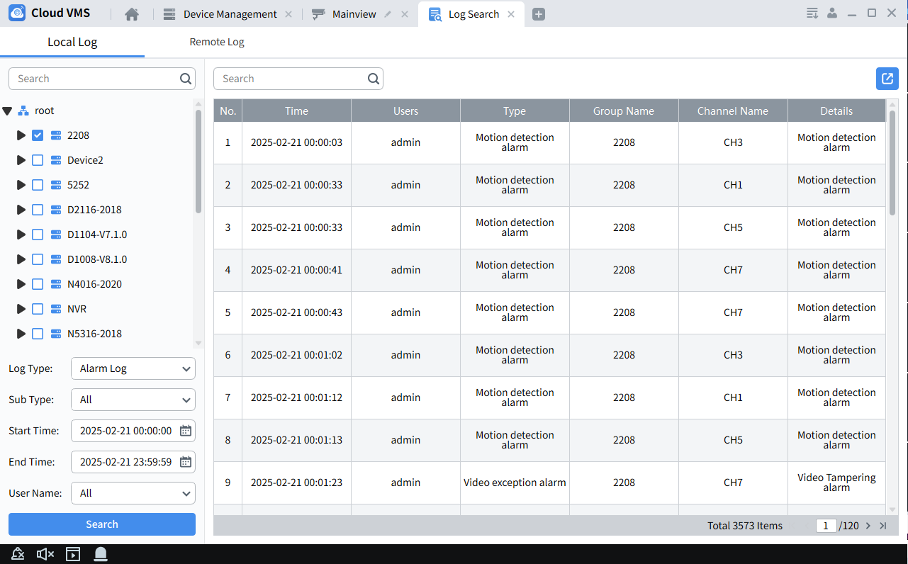
Note: The searched logs can be saved to the specified directory by setting the path through the page export button .

7.2 Query Remote Device Logs
Step 1: Select " Log Search " in the main menu to enter the log query interface.
Step 2: Enter the Remote Log page.
Step 3: Select the device to be searched and set the search conditions according to actual needs. The search device logs include system logs, configuration logs, alarm logs, user logs, video logs, storage logs and intelligent logs.
Step 4: Click "Search" to start the search. The system displays the device log search results, as shown in the figure.
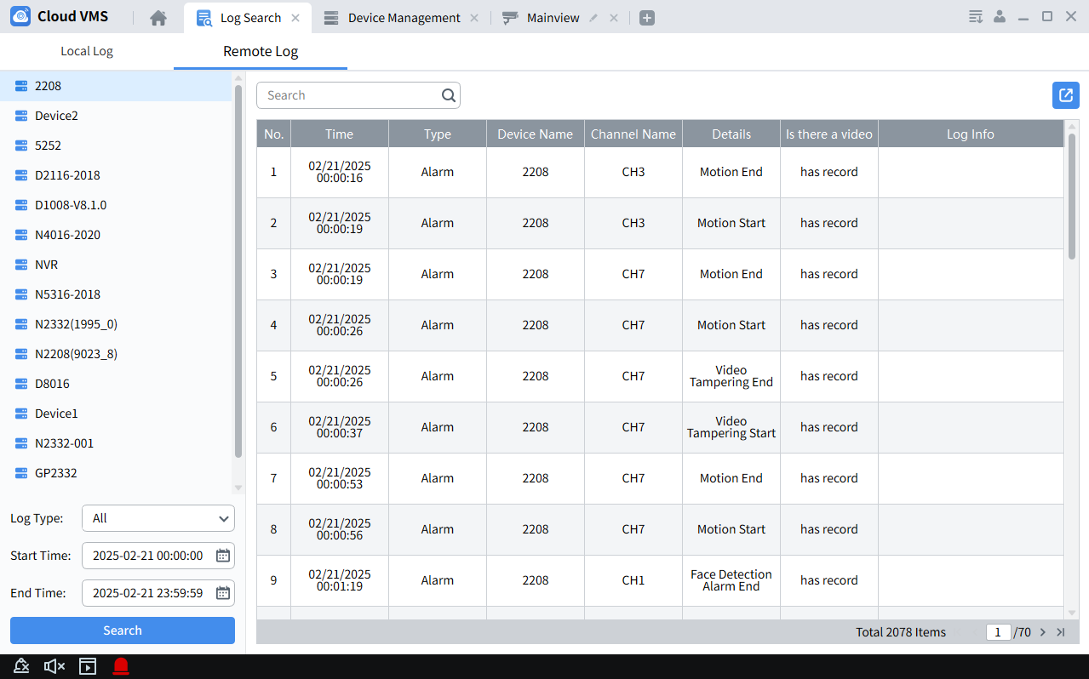
Note: The searched logs can be saved to the specified directory by setting the path through the page export button.

Chapter 8 Topology Management
Used to manage lightly managed POE switches and display network topology. To use this function, ensure that the switch has been successfully added to the client and is online.
In the topology display interface, you can view the topological relationship between the devices added by the client and perform related configuration operations.

8.1 Related Operations
On the Cloud VMS main page, Clickpology Management to enter the topology display interface.
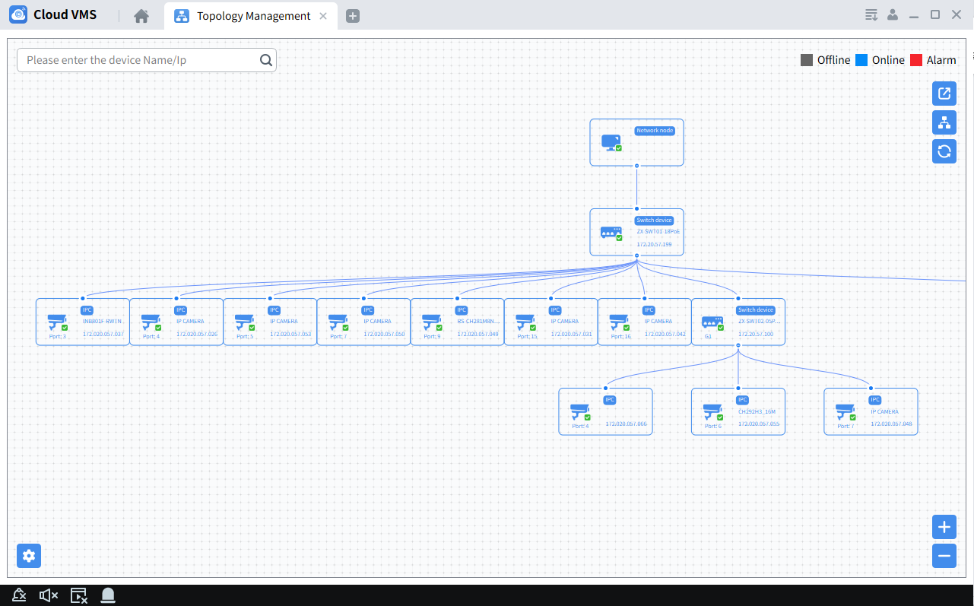

Interface Description
- In the upper left corner, you can enter the device's alias or IP to view the corresponding topology map,
- The upper right corner shows the meaning of the icon color, export and refresh the topology map, and display the path,
- Zoom in or out the topology map in the lower right corner, or use the mouse wheel to zoom in or out directly,
- Set the display level of the topology map in the lower left corner.
Illustrate:
When you enter the topology map display interface for the first time, if the topology map is not displayed, please click Refresh to try again.
The related operations/icons are described as follows.
Double-click the device: view device details, display device type, IP, panel status and port information.
Right click device:
(1) Check device status: Turn to the "Device Status" interface, see device status for details.
(2) Perform alarm processing: Display alarm and event information, and perform alarm elimination operations.
(3) Perform remote configuration: Turn to the "Remote Configuration" interface.
(4) Modify device name: Modify the display name of the device in the topology interface.
(5) Set as root node: Set the current device as the root node on the topology map.
(6) Upgrade device: Support upgrade of NVR/DVR/network camera connected to the device.
Export topology map, select export path, export current topology map.
Display the path, select the network camera and the current device, and display the path between the selected devices.
Refresh the topology map, refresh and display the topology map interface.

8.2 Topology Settings
Procedure
Click the lower left corner of the interface to make simple settings for the topology map.
- Set the display layer number of the topology map: 1 ~ 10 ,
- Click OK to save your settings.
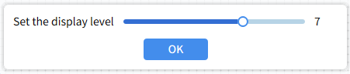
Illustrate:
After changing the settings, you need to click Refresh to display the latest topology map.

Chapter 9 AI Search
The smart search page supports searching, counting and configuring the device's faces, pedestrians and vehicles, license plates and repeated visitor data.

9.1 Face​

9.1.1 Face Search
Click “AI Search" in the main menu to enter the search interface, and select Face---Search, as shown in the figure.
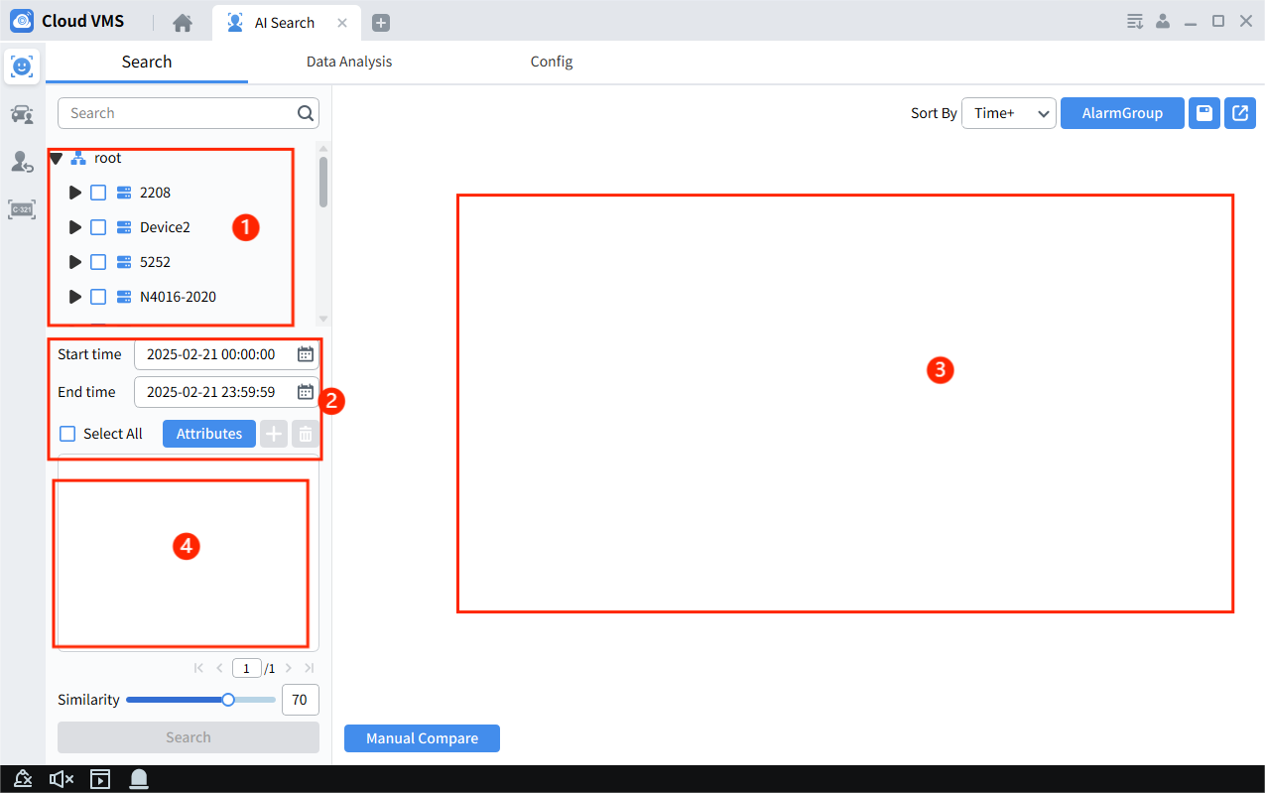
1. Device area: Displays devices that support search.
2. Search condition settings: Set the search time period and specific attributes.
3. Search result display area: Displays the face images searched according to the set conditions.
4. Search by image: In this area, you can add local or device face images, set similarity, and search.

9.1.2 Face Statistics
Click“AI Search”in the main menu to enter the search interface and select Face---Data Analysis, as shown in the figure.
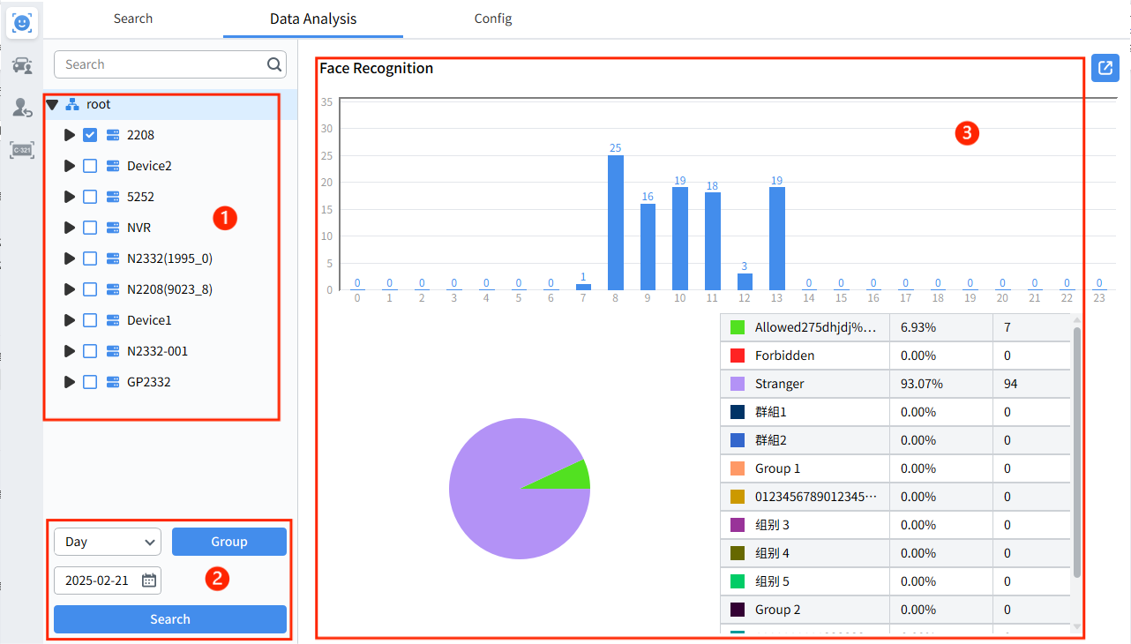
1. Device area: Displays devices that support search.
2. Search condition settings: set the search range, date and face grouping.
3. Search result display area: displays the face statistics found according to the set conditions.

9.1.3 Face Configuration
Click“AI Search”in the main menu to enter the search interface, select Face---Configure, as shown in the figure.
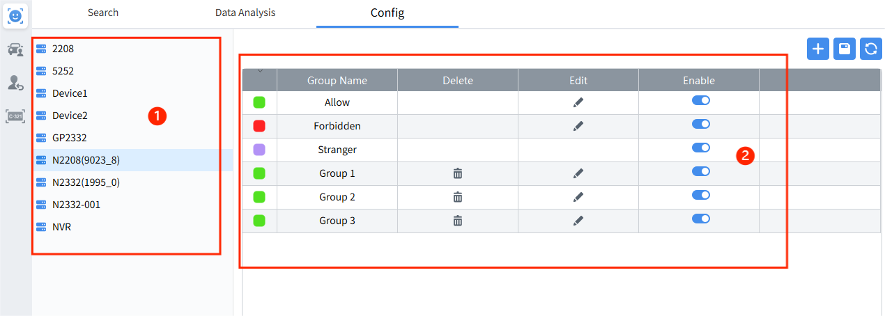
- Device area : Displays devices that support settings
- Face group operation area : You can add, modify, and delete face groups.
Note: The device can add up to 16 face groups . The default three groups “Allow list” , “Block list” and “Stranger” cannot be deleted .
Select a face group and click the button to enter the face group setting page, as shown in the figure.
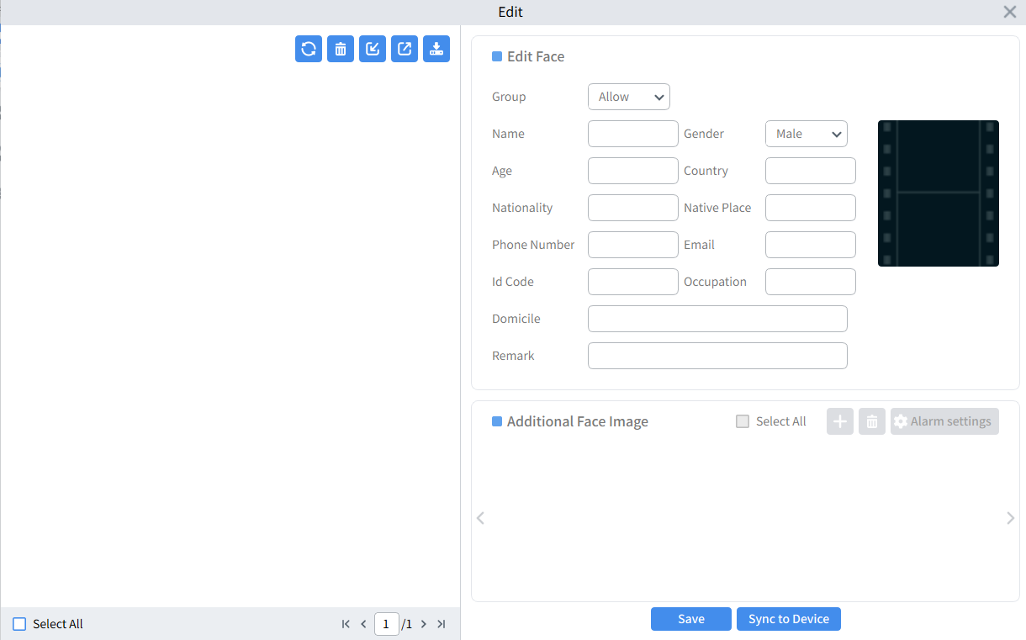
Click button to pop up the import method selection menu, as shown below picture.
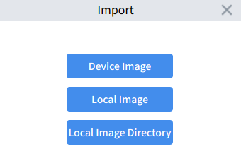
Device Image: Search for face images captured by the device and select and import them into the specified group.
Local Image: Select the face image saved in the local directory and import it into the specified group.
Local Image Directory: Select the directory where facial images are stored locally and import them into a specified group in batches.
Select the face image in the current group, click the Export button, and select the local save path to export the face image to the local computer.
Click Download import template and select a local save path to download the import template to your local computer. After editing according to the template file instructions, you can directly import the .csv file under Local Image to upload images and related information in batches.
Select the face images in the current group and click the Delete button to delete the selected images in the current group.
Click Refresh to refresh the current group.

9.2 Pedestrians And Vehicles

9.2.1 Pedestrian And Vehicle Search
Click “AI Search”in the main menu to enter the search interface, select Pedestrians and Vehicles---Search, as shown in the figure.
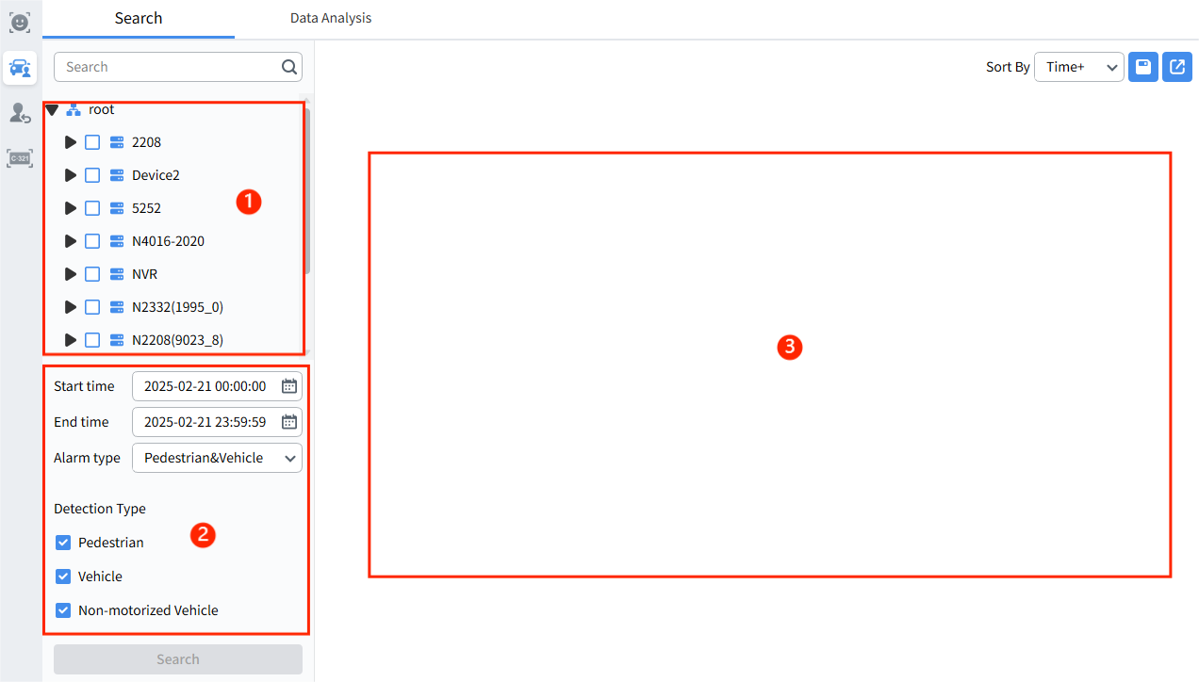
- Device area: Displays devices that support search
- Search condition settings: set the search period , alarm type and detection type
- Search result display area: displays the screenshots found according to the set conditions.
Select the searched pedestrian and vehicle events, click view event details, click play the event, click export the video, and click export pedestrian and vehicle pictures.
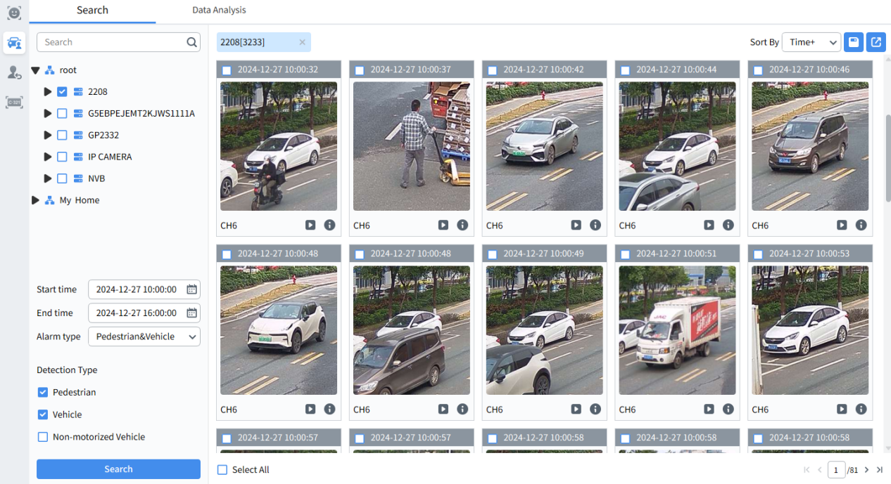

9.2.2 Pedestrian and Vehicle Statistics
Click“AI Search”in the main menu to enter the search interface and select Face---Data Analysis, as shown in the figure.
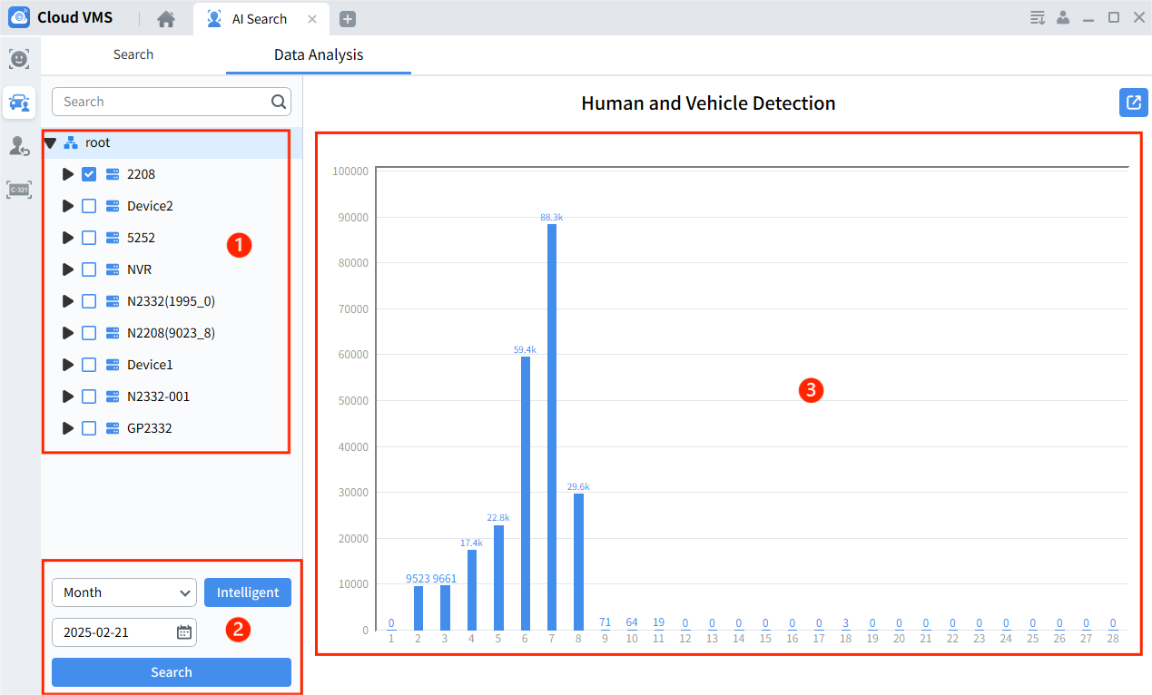
1. Device area: Displays devices that support search.
2. Search condition settings: Set the search range, date and smart type.
3. Search result display area: Displays the pedestrian and vehicle statistics found according to the set conditions.
Click export data analysis results to local (Note: Data is saved in Excel format)
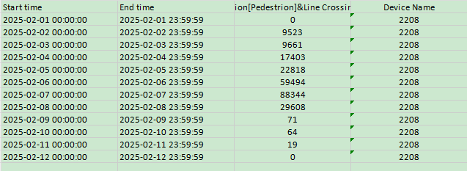

9.3 Repeat Visitor Search
Click “AI Search” in the main menu to enter the search interface and select repeat visitor search, as shown in the figure.
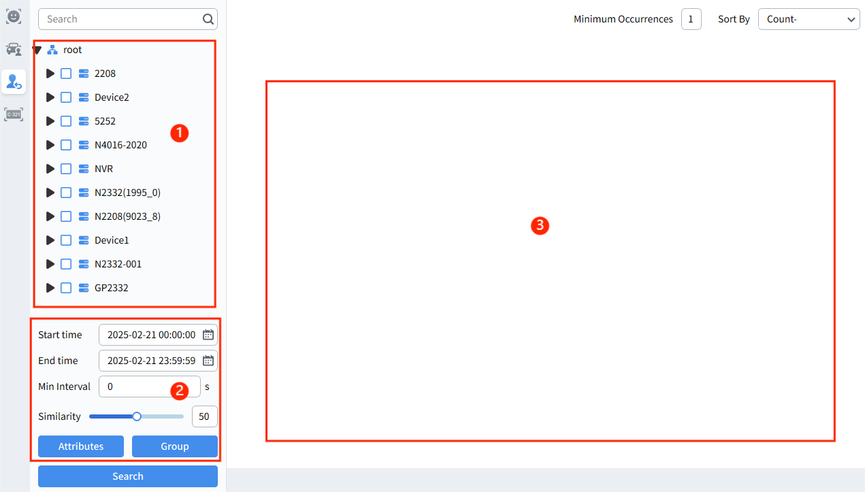
1. Device area: Displays devices that support search
2. Search condition settings: Set the time period, minimum capture interval and similarity to search for the number of occurrences, and filter by attributes and groups.
3. Search result display area: Display the profile pictures and the number of times the person is searched based on time.
Select the searched repeated visitor and double-Click view the specific snapshot event of the visitor. Click play the event.
Select an event and click export the video or click export the face image.
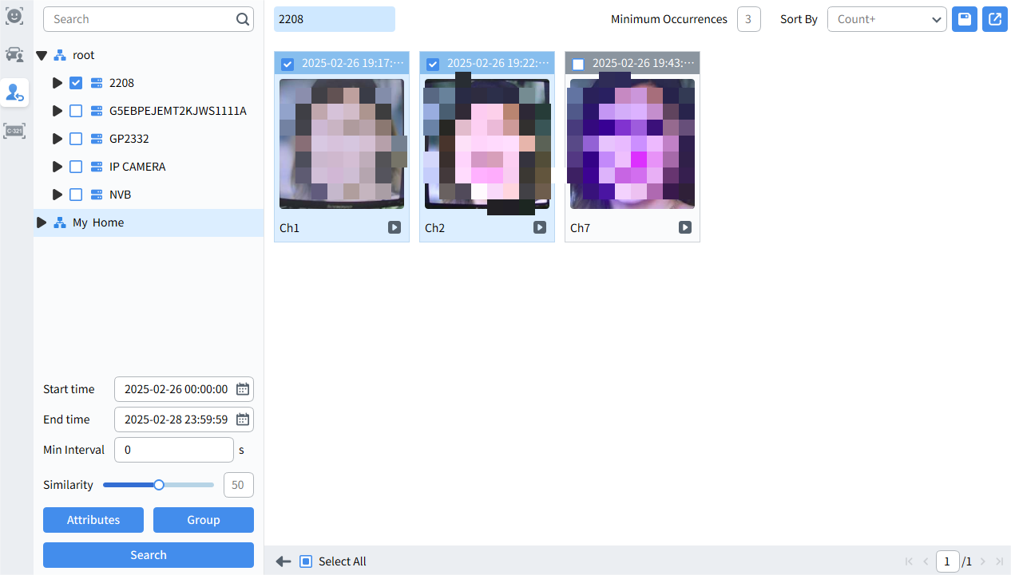

9.4 License Plate

9.4.1 License Plate Search
Click “AI Search” in the main menu to enter the search interface, select License Plate---Search, as shown in the figure.
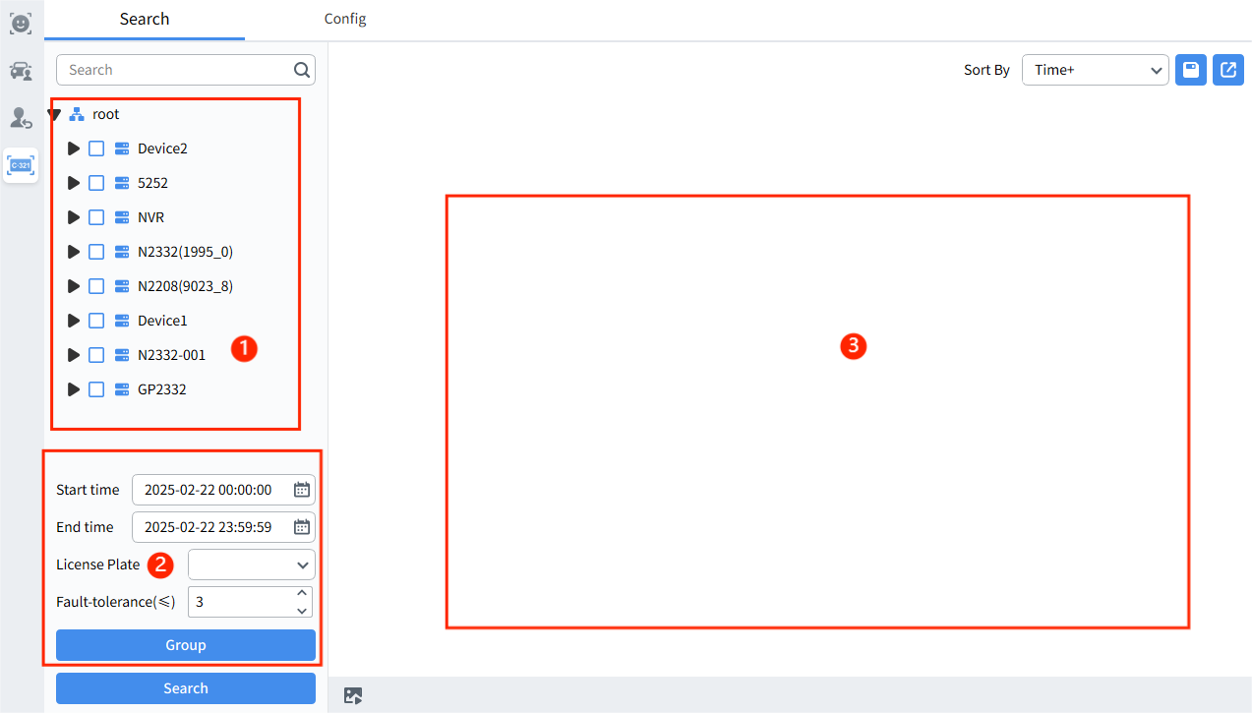
1. Device area: Displays devices that support license plate recognition.
2. Search condition settings: Set the search date, search group, search license plate, and set the number of characters allowed for license plate errors.
3. Search result display area: Display the search results based on the set parameters.
Note: Tolerance character, the number of characters that are allowed to be inconsistent between the license plate number displayed in the search results and the set license plate number. The lower the setting, the higher the search result matching degree.
Select the searched license plate, click view event details, click play the event, click export the video, click export the license plate image.
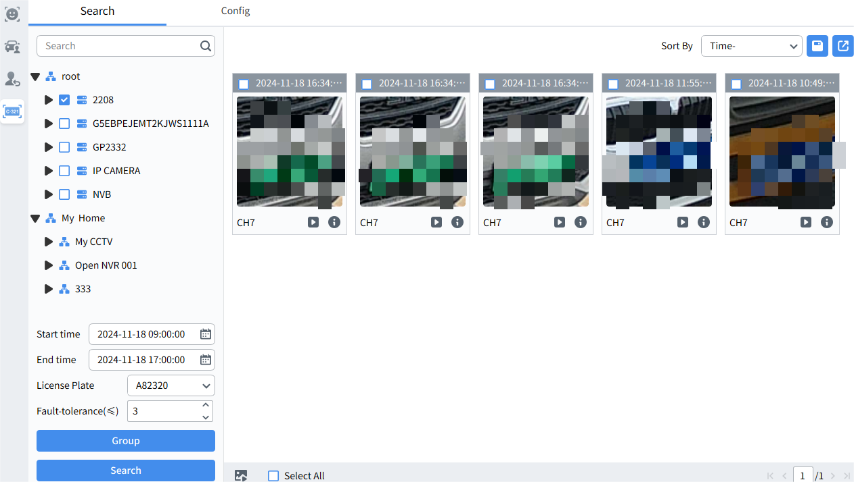

9.4.2 License Plate Configuration
Click “AI Search” in the main menu to enter the search interface and select License Plate-Configuration, as shown in the figure.
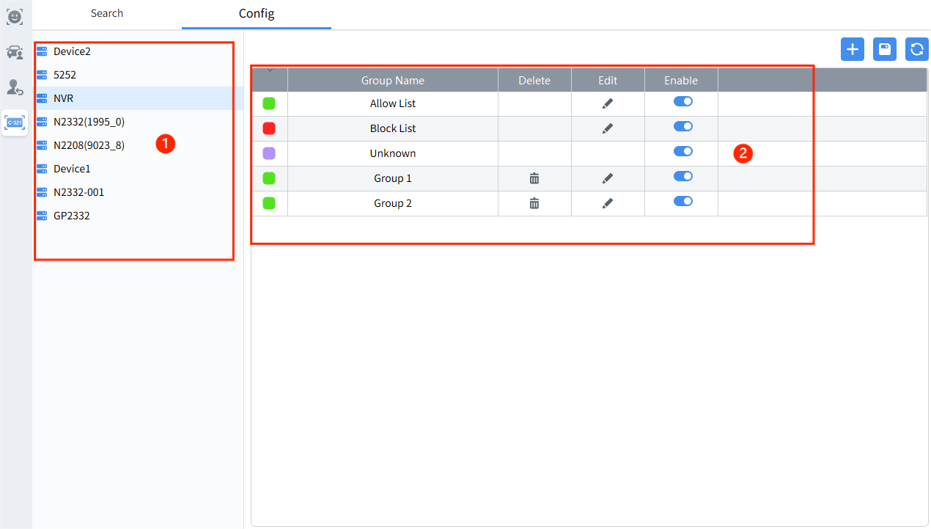
1.Device area: Display devices that support settings
2.License plate group operation area: license plate groups can be added, modified and deleted.
Note: The device can add up to 64 license plate groups. The default three groups “Allow list”, “Block list”, and “Unknow” cannot be deleted.
Operation steps: Select a group and click enter the license plate information setting page, as shown below picture.
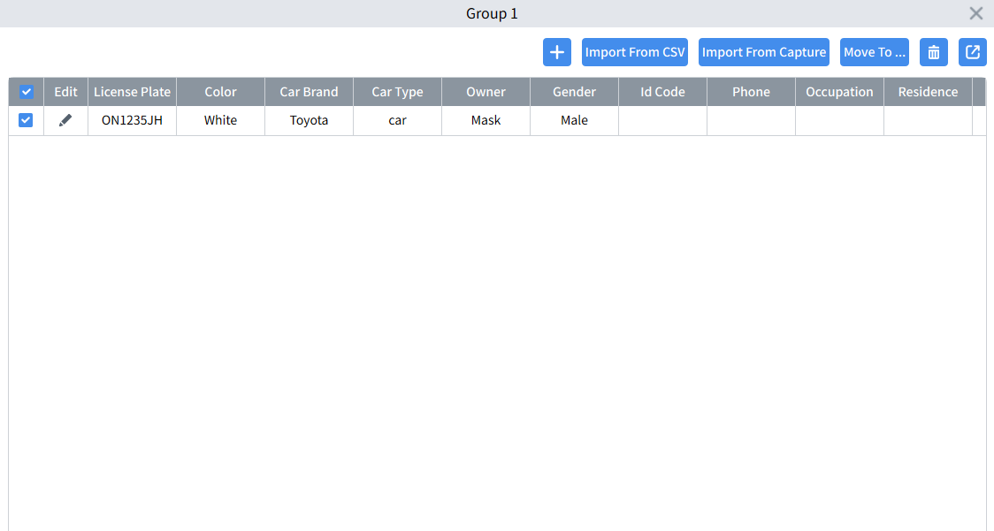
Click pop up the license plate information entry menu, as shown below
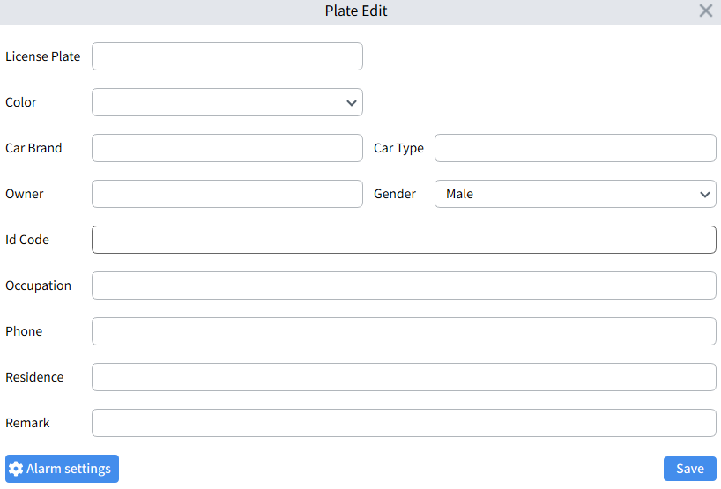
On this page, you can enter license plate information and set the associated audio and alarm channels when the license plate is recognized .
Click the Export button and select the local save path to export the license plate information in the current group in .csv format.
Click Import form CSV, select the local .csv file, and import vehicle information in batches.
Click Import form Capture, and you can search the license plate recognition images captured by the device on the pop-up page. Select the image based on the search results to edit the information and import.
Click Move to to transfer the selected license plate information from the current group to another group.
Click Delete to delete the selected license plate information.

Chapter 10 Attendance Management

10.1 Attendance Records
Click“Attendance management”in the main menu to enter attendance management---attendance record, as shown in the figure.
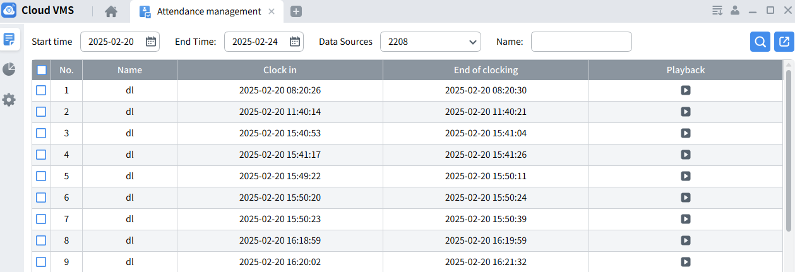
On this page, you can select the search device, set the search period, the name of the attendance personnel, and query the attendance record. The attendance record contains the start and end time of the face event trigger, and you can directly play back the event video associated with the record.
Note: The attendance function is based on face recognition. Therefore, to use this function, you must ensure that face recognition is enabled on the device, face images have been imported into the list group, and face recognition comparison is normal.

10.2 Attendance Statistics
Click“Attendance management” in the main menu to enter attendance management---attendance statistics, as shown in the figure.
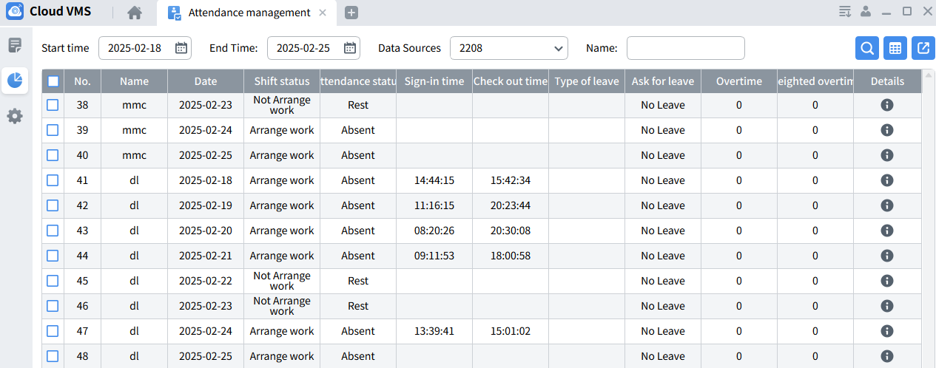
On this page, you can select the search device, set the search period, attendance personnel name, and conduct attendance statistics query based on the attendance rules that have been set.
Attendance statistics include: attendance date and punch-in time, shift status, attendance status, leave status, overtime status, etc.
Note: The attendance result here is calculated based on the parameters set by the attendance rule. Adjusting the attendance rule parameters will affect the result statistics here.

10.3 Attendance Management
Click“Attendance management”in the main menu to enter attendance management---attendance settings.
1. Basic rules​
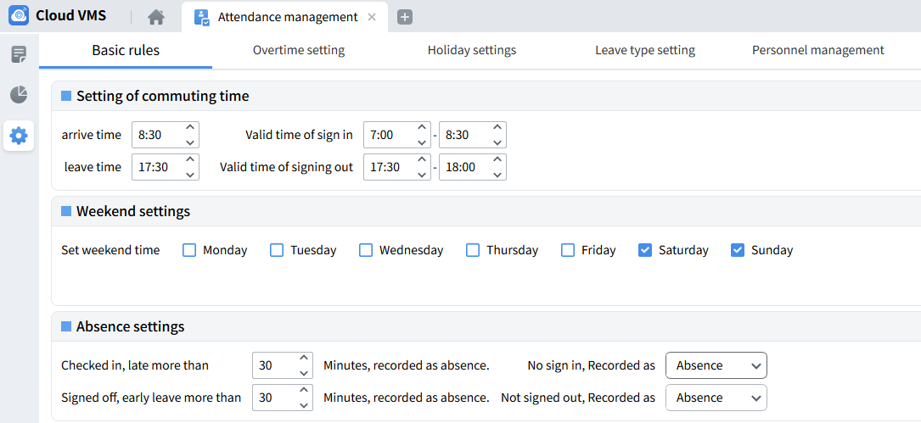
: Set the working hours and the effective time period for clocking in and out
: Set the weekend period, and attendance will not be recorded on the selected date.
: Absence setting. If you have signed in, if you are late for more than X minutes before the working time, it will be recorded as absence. If it is 0, it means this rule is not effective. If you have signed out, if you leave early more than X minutes before the end of the working time, it will be recorded as absence. If you have not signed in or signed out, you can choose to set it as absence/early leave.
Note: The settings here will affect the results of attendance statistics and need to be set according to actual attendance needs.
2. Overtime setting​
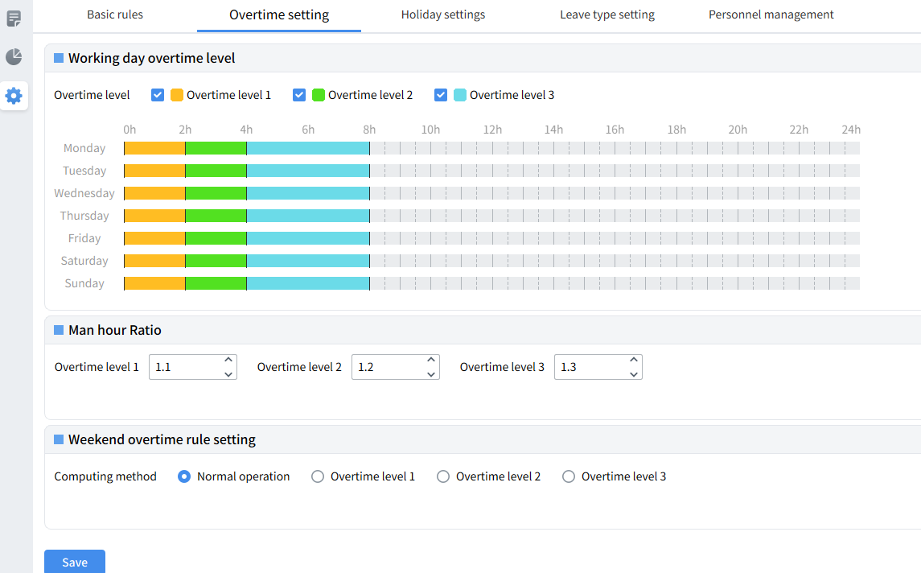
: Working day overtime level setting, divided into three overtime levels , the corresponding overtime level is checked to indicate selection , you can drag the corresponding color bar in the drawing area to set the time range set for the overtime level .
: Working hours ratio, you can set the working hours ratio corresponding to each overtime level
: Weekend overtime rules , set the overtime level for weekend overtime
Note: The settings here will affect the results of attendance statistics and need to be set according to actual attendance needs.
3. Holiday settings​
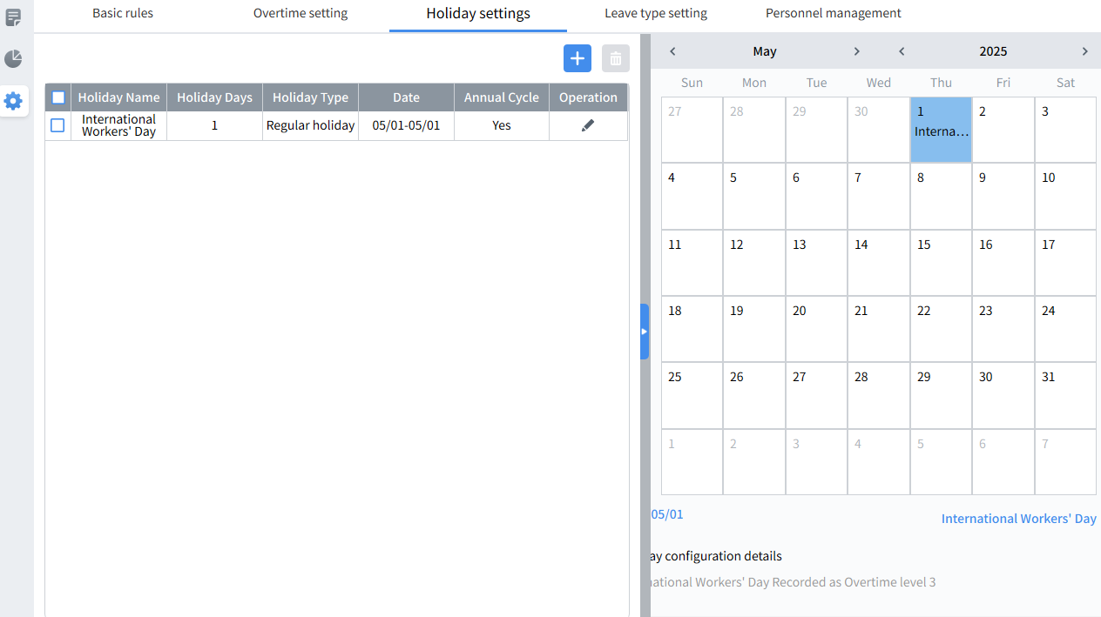
Click open the holiday setting menu and select the holiday type.
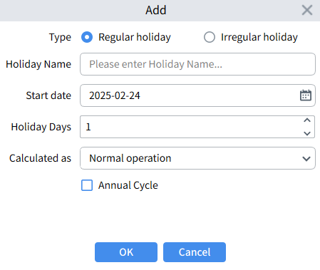
You can fill in the holiday name, start time (calendar format), number of days off, overtime level, and whether it recurs annually.
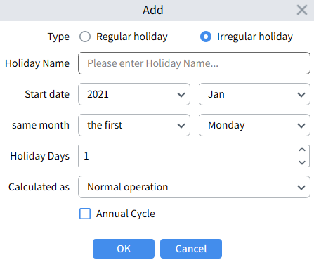
The difference is that the time when the holiday starts is set. Because the date is different every year, it is expressed according to the day of the week of a certain month in a certain year.
Click delete the added and selected holiday settings.
4. Leave type setting
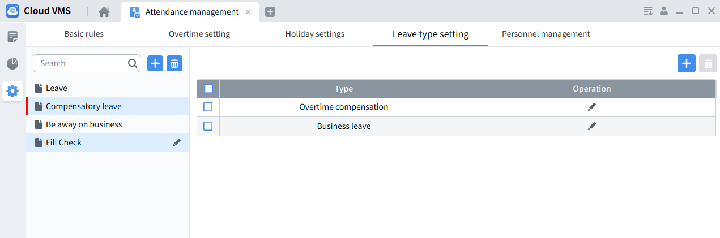
On this page, you can add or delete leave types as needed.
Note: The leave type set here is used on the personnel management page to mark the type of personnel leave.
5. Personnel management​
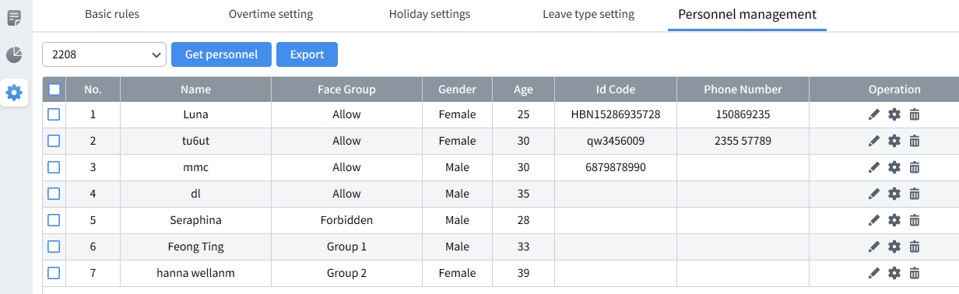
Click open the personnel information setting menu and modify the personnel information in the current device.
Click sign in the selected person, as shown in the figure.
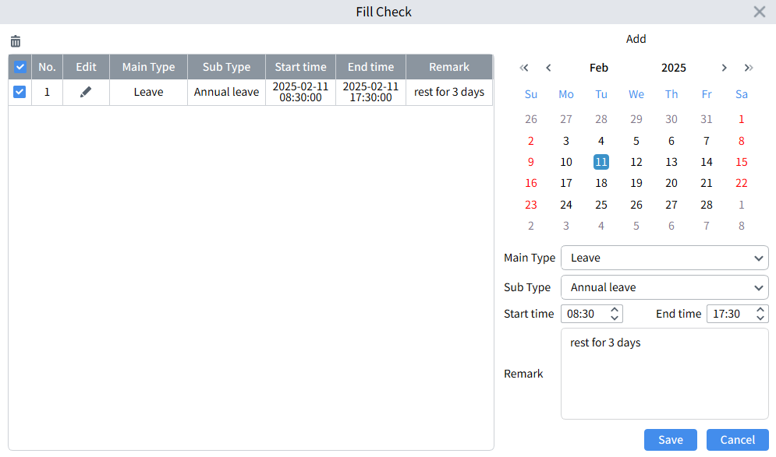

Chapter 11 Alarm Settings

11.1 Alarm Event Display
Click “Alarm Config” in the main menu to enter the alarm operation interface and select the alarm event, as shown in the figure.
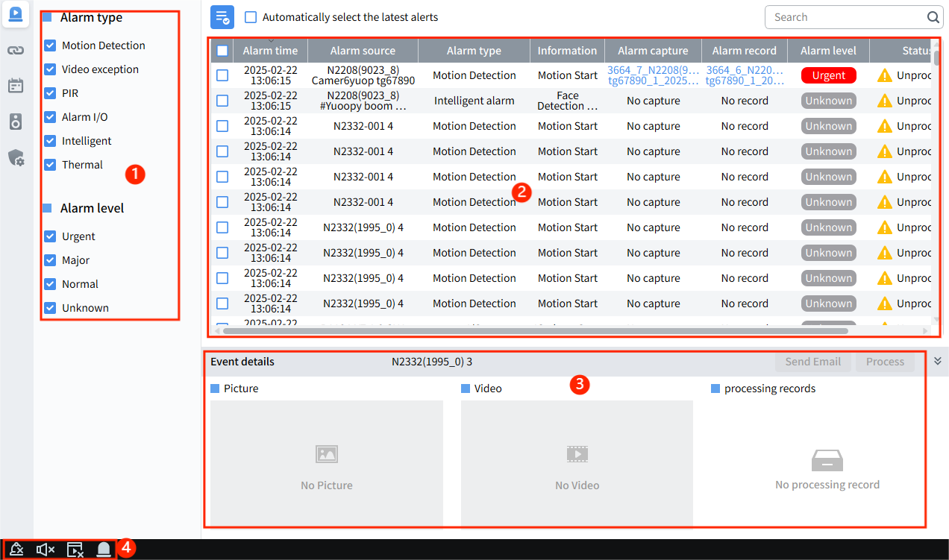
1. Alarm type and alarm level:
Alarm Type: Set the alarm type displayed in the window. Only the selected alarm type information will be displayed in the message window.
Alarm Level: Set the alarm level displayed in the window. There are four levels: urgent, important, normal and unknown, the message window will be displayed only for the selected alarm level (Note: the alarm level needs to be set on the alarm linkage page ).
2. Alarm information display area:
This area displays the alarm status of online devices in real time (Note: the channel schedule status can be set on the alarm linkage page to control the display of alarm messages here).
3. Alarm event details area:
If the alarm channel has enabled alarm linkage snapshot and video recording on the alarm linkage setting page, you can see the screenshots and videos associated with the alarm when you select the alarm information , and you can play the videos.
Click the Send Email button to send the current alarm information to the set email address.
Click or Process button to comment on all or individual alarm events .
4. Click clear the alarm information display, click turn the alarm volume on or off.
Click set the real-time alarm pop-up, Close: no pop-up window, Open: pop-up window will be displayed at the top of the page when there is an alarm
Full screen: When an alarm occurs, the pop-up window is displayed in full screen, Click view the abnormal alarm record of the device.

11.2 Alarm linkage settings
Click “Alarm Config” in the main menu to enter the alarm operation interface and select alarm linkage, as shown in the figure.
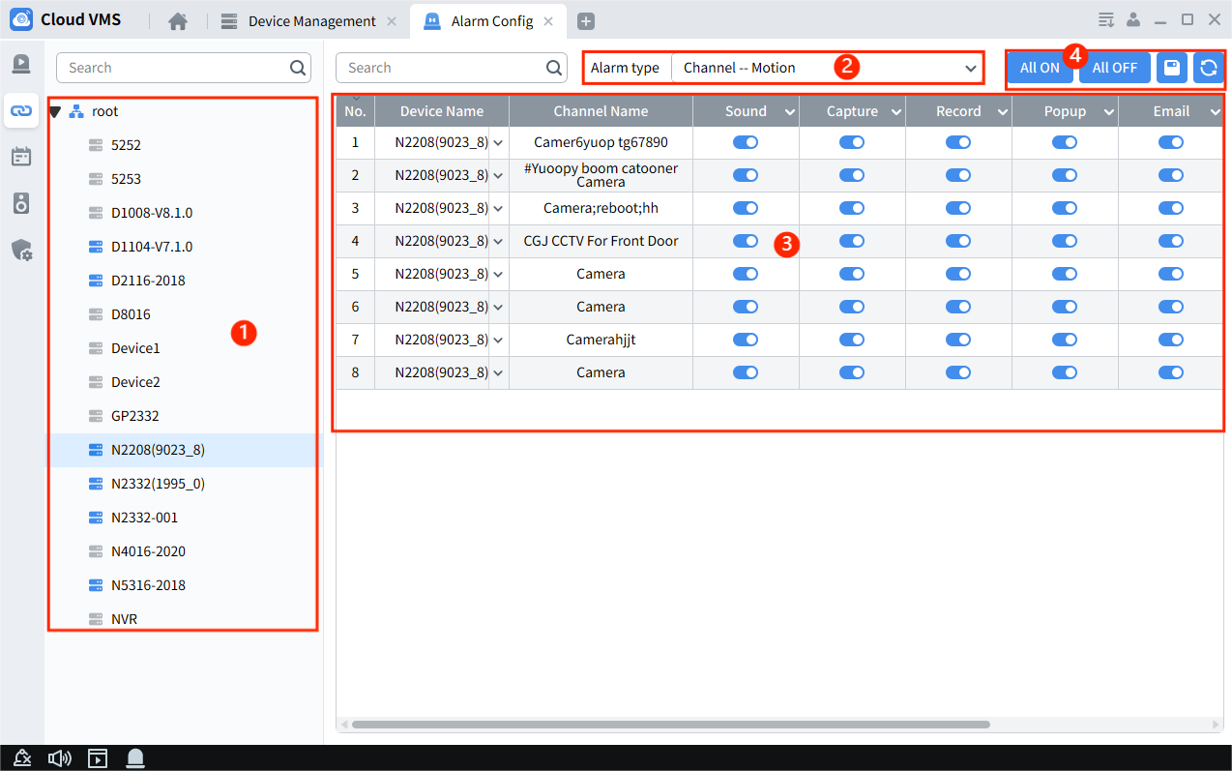
- Device area: displays devices that support settings (Note: the device must remain online) .
2. Alarm type selection: including normal alarm, AI analysis and AI. Click to expand the alarm type options and select the alarm type setting as needed .
3. Alarm linkage settings: Support settings for Capture, Record, Popup, Sound, Email, Schedule and Alarm level .
4. Operation settings:
All ON: All options are turned on
All OFF: All options are turned off
Refresh: Refresh the current page
Save: Save settings

11.3 Schedule Settings
Click “Alarm Config” in the main menu to enter the alarm operation interface and select the schedule, as shown in the figure.

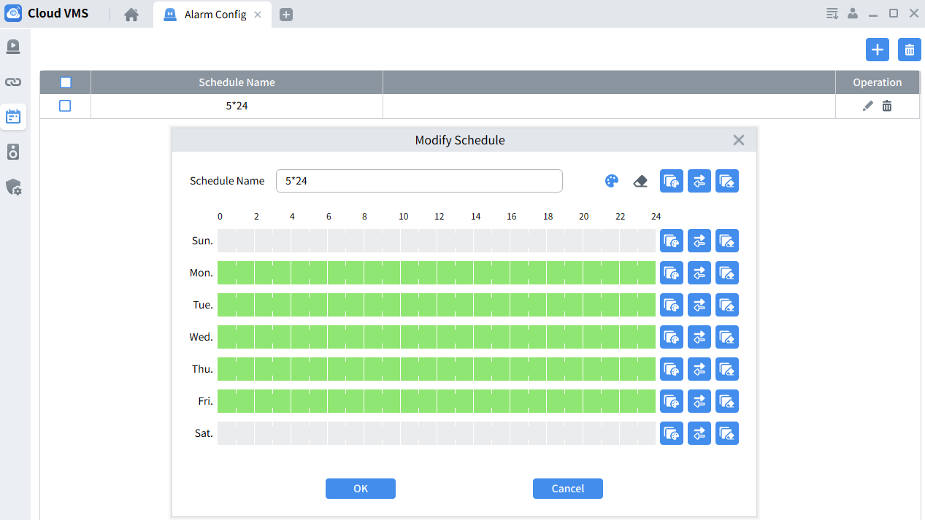

On this page, you can add, delete, and modify schedules. The schedules can be applied to alarm linkage channel settings and local recording schedule settings.

11.4 IP Speaker Linkage Settings
Click “Alarm Config” in the main menu to enter the alarm operation interface and select IP Speaker alarm settings, as shown in the figure.
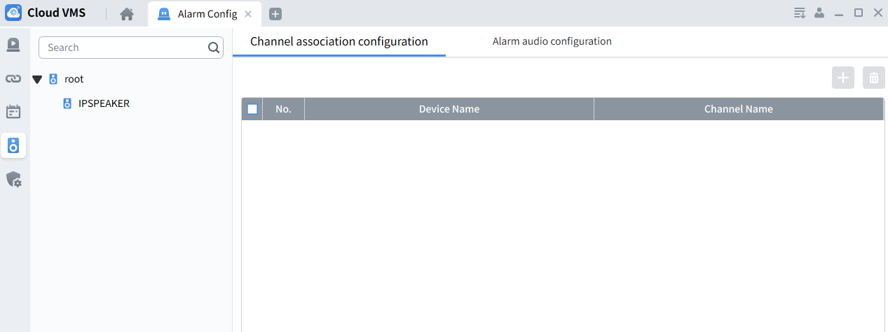
Note: To configure this function, you need to add IP Speaker to CVMS and go online.
Operation steps:
1. Bind device channel: Click the Add button, select the device channel to be bound in the pop-up menu list, and click to add to Bind Device List.
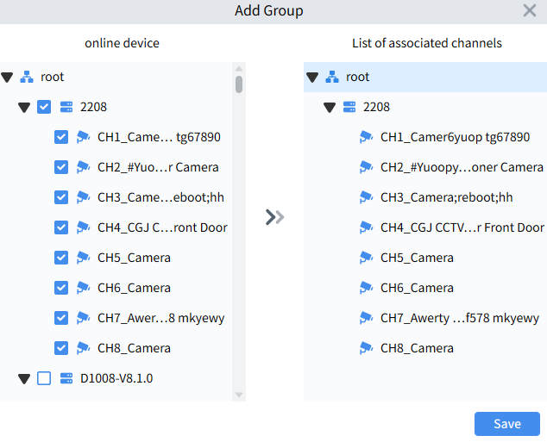
- Go to the preview page to preview the bound device channel, click the channel speaker--intercom button to speak on the PC side and output on the speaker.
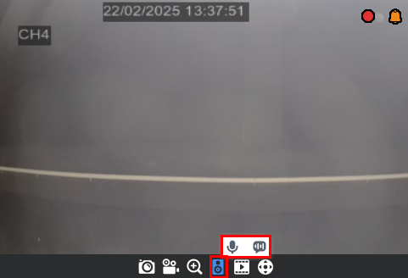
- Click the channel speaker--broadcast button to open the broadcast setting menu, where you can enter text to convert audio or import audio files to broadcast the speaker at a set number of times.
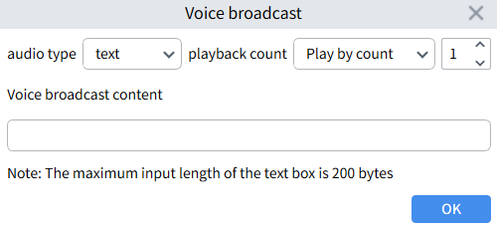

11.5 Device Disarming
On the device disarm page, you can disarm/arm devices that have the alarm disarm/arm function.
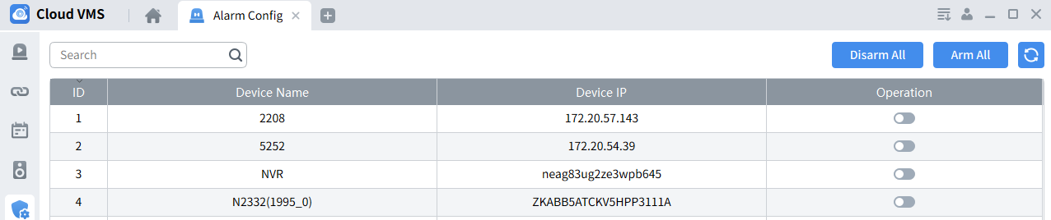

Chapter 12 Local Record
1. Click " Local Record " in the main menu to enter the local video management interface. On this page, you can configure the local video storage partition and directory, and set the video overwrite method, as shown in the figure.
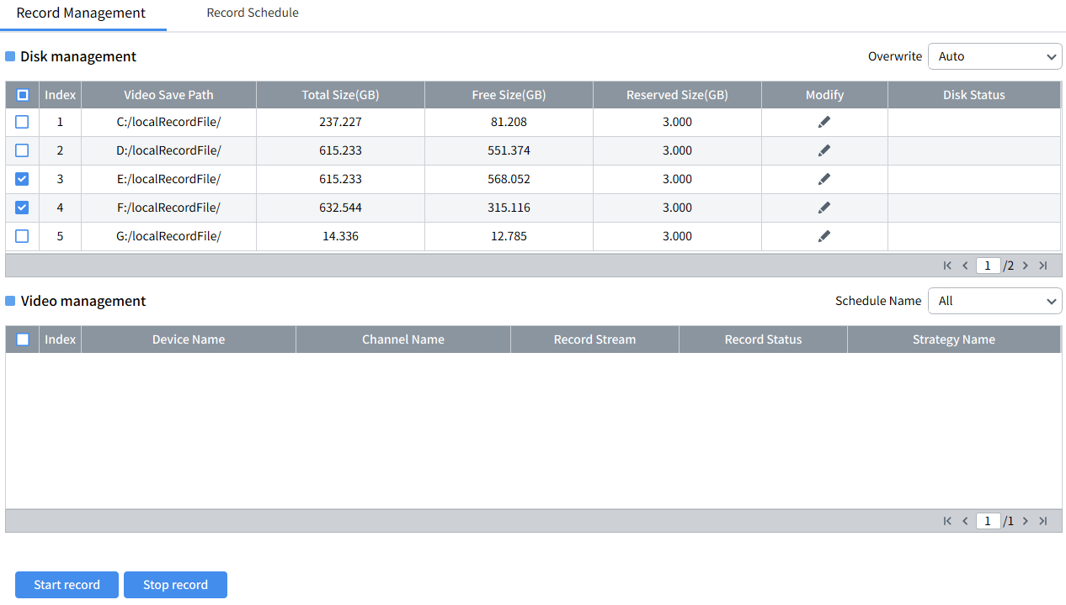
2. Click " Record Schedule " to enter the recording plan setting interface, check the device channel that needs to be recorded in the device list, set the plan name, recording file length, recording bit rate, and use schedule. After the settings are completed, click " Save " to save, as shown in the figure.
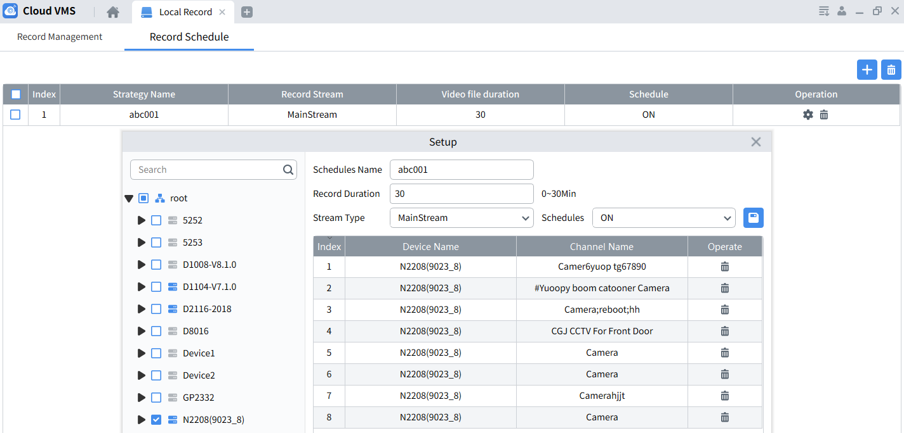
3. After the settings are completed, enter the "Record Management" interface, select the added channel in the video management list, click start record to start local recording, and click stop record to stop local recording, as shown in the figure.
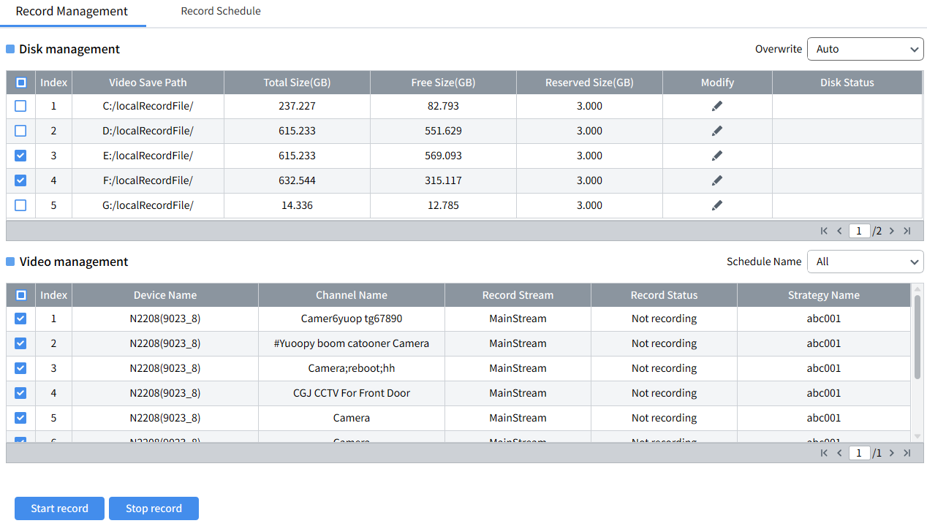
4. Return to the main menu, enter“Playback---Local Playback”, select the device channel configured for local recording, and perform recording search and playback, as shown in the figure.
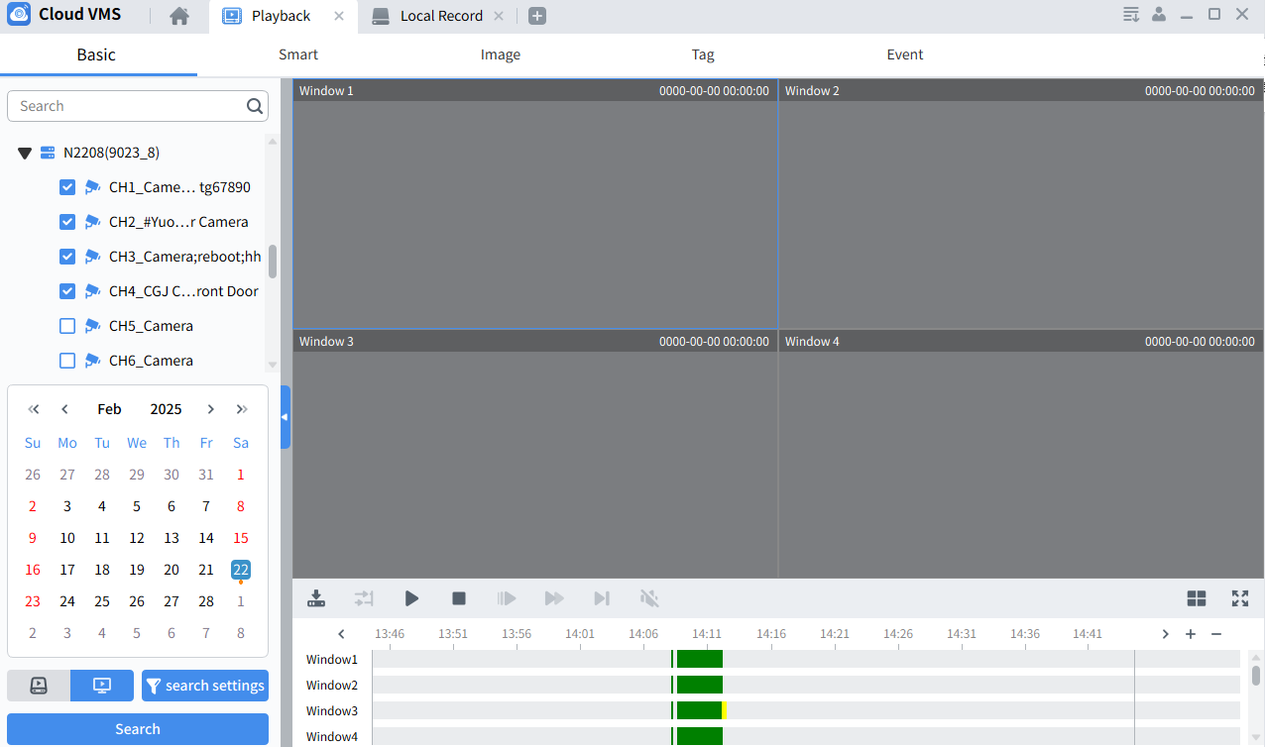

Chapter 13 System Configuration
Click “System Config” in the main menu to enter the system configuration interface, as shown in the figure.
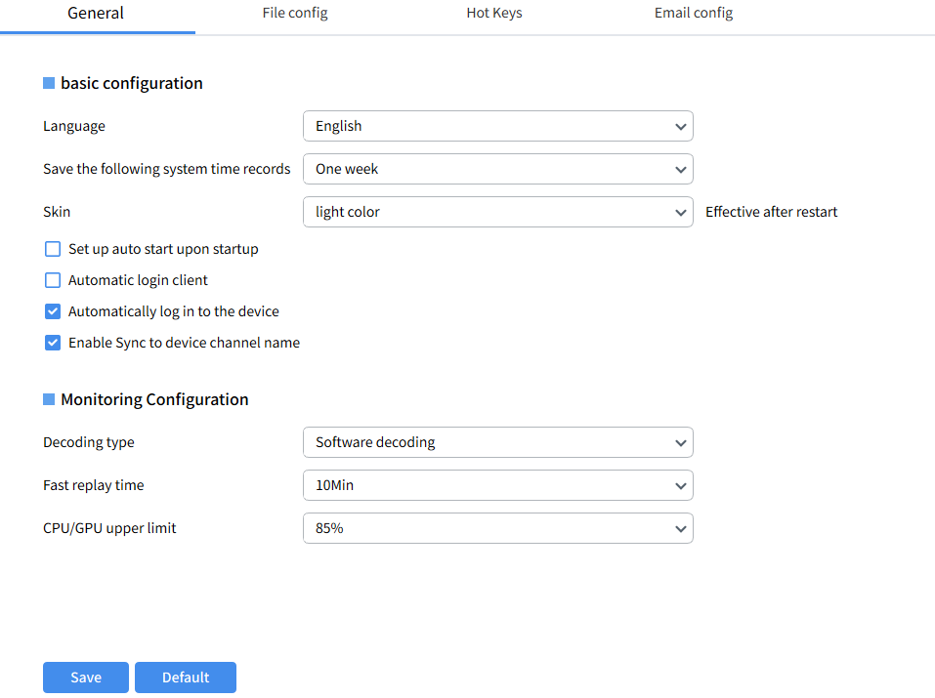
Configure system parameters. The specific parameters are as follows :

13. 1 General​
Language: System language settings
Keep System Logs: System log retention period, there are three options: One week , half of month and a month.
Setup auto start upon startup: Automatic startup upon startup.
Automatic login: Automatic login CVMS.
Automatically log into device: Automatically log in to the device. When logging in to Cloud VMS , the connected device automatically logs in and goes online. Uncheck the option to log in to Cloud VMS and all devices are offline.
Enable Sync to device channel name: Enable synchronization of device channel names. When the device changes the channel name, it will automatically synchronize to the corresponding channel in cvms.
Decoding type: Software decoding relies on the CPU for decoding, which consumes a lot of CPU, hardware decoding relies on the GPU for decoding, which reduces the consumption of the CPU.
Fast playback time: Instant playback recording time setting, supports 1min, 3min, 5min, 10min
CPU/GPU Upper Limit: Set the CPU/GPU usage limit during preview or playback. If the usage exceeds the set limit, the preview channel will be automatically closed to reduce the CPU/GPU load.

13.2 File Config
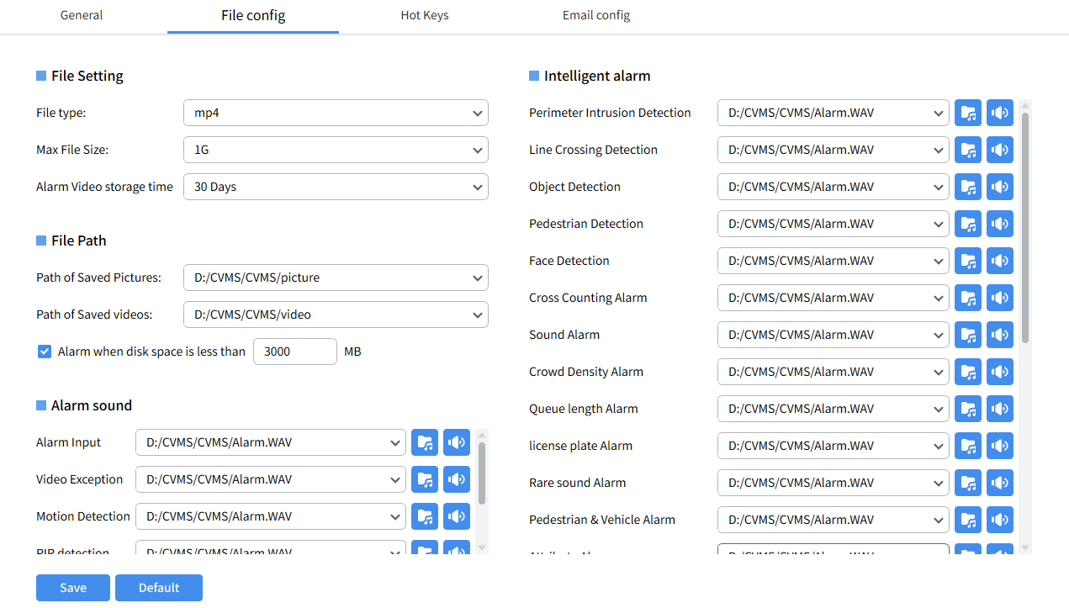
File type: file save type, including the following options: avf , AVI , mp4
Max File Size: The size of a single video file. The options are as follows: 1G , 2G (AVI format only supports 1G video files)
Alarm video retention period: Alarm video retention period, optional 7/30/90/180/365days
Path of Saved Pictures: Set the save path of local picture files.
Path of Saved Videos: Set the save path of local video files.
Alarm when disk space is less than ___MB: Set a value, when the disk free space is less than this value, the system will issue a warning. Check and set the value, the minimum setting is 500MB .
Alarm Sound: Set the corresponding alarm sound when various alarms are triggered

13.3 Hot Key
Maximize VMS ( open full screen ) : F2
Mainview ( open preview ): F3
playback ( open playback ): F4
System config ( Open system settings ): F5
Alarm event ( open alarm ): F6
Cruise Setting ( Open Cruise Setting ): F7
Device Management ( Open Device Management ): F8
Lock Screen ( lock screen ): F9
Switch user : F10
Open/Close alarm sound : F11
Local Record ( open local recording ): CTRL + R
You can quickly open a module through shortcut keys. The above shortcut keys are the default shortcut keys, and users can modify them according to their usage habits .
4. Email config (email settings) sends the alarms received by Cloud VMS to the specified email address. You need to enable the alarm email function on the alarm settings page:
Email: Email settings switch
Encryption: Enable if your email server requires SSL or TLS authentication. If you are unsure, set to "Auto".
SMTP Port: Enter the SMTP port of your email server
SMTP Sever: Enter the SMTP server address for email
UserName: Enter the user's email address
Password: Enter the user's email password
Sender: sender name
Receiver 1-3: Enter the email address where the user will receive event notifications from Cloud VMS.
Interval: Configure the time interval between Cloud VMS notification emails. The default value is 3 minutes.
Test: To ensure that all settings are correct, click “Test Email” and the system will send an email to the user's inbox. If the user receives the test email, it means that the configuration parameters are correct.

Chapter 14 AI Configuration

14. 1 Model configuration​​
Click “AI Config” in the main menu to enter the AI configuration operation interface and select model configuration, as shown in the figure.
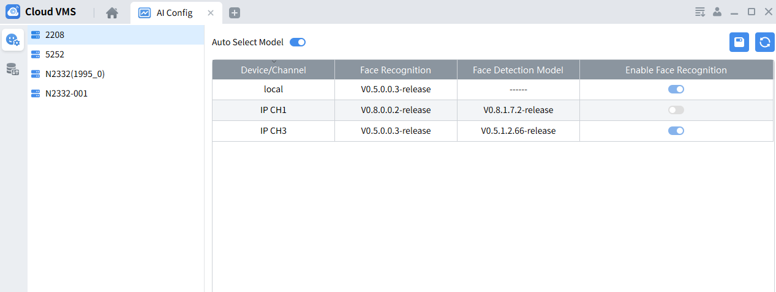
On this page, you can select devices that support face recognition and set how to use the face recognition model. Automatic mode: local models and camera models that are consistent with the local model version will be used first.
Manual mode: The face model needs to be enabled manually.

14.2 DataBase synchronization​​
On this page, you can back up and import the face and license plate database of the device .
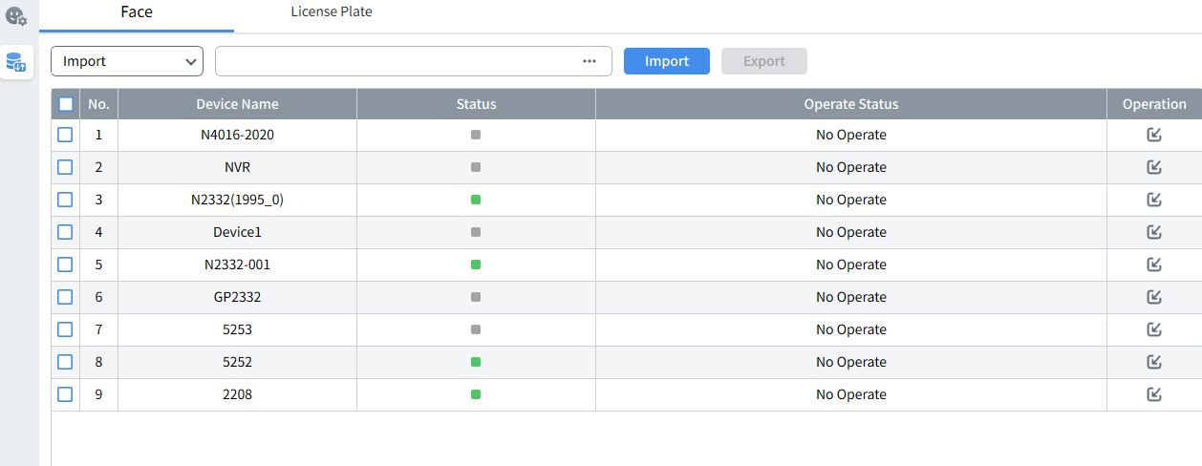
For example, select the operating device, select the operation type as Export, save the path, click , perform password authentication, proceed to “Export”, the export is completed and the status is “success”.

Chapter 15 Electronic Map

15.1 Create / modify map
Step 1: Click“Emap Config”in the main menu to enter the map configuration interface, click “Add Emap”in the interface, and the system will pop up the map selection dialog box, as shown in the figure.
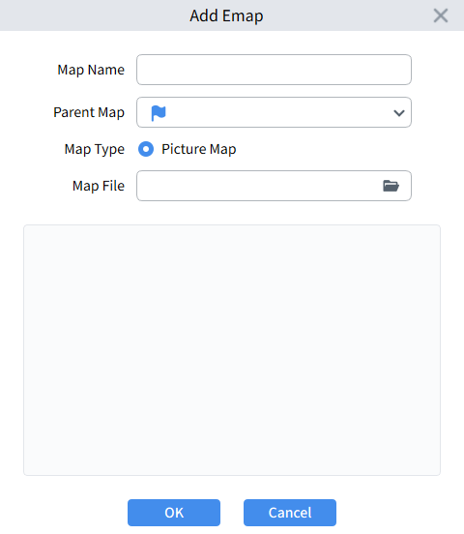
Step 2 : Set the map name, select the image path , and complete import maps.
Step 3: Click "Modify Emap" and you can modify the map name in the pop-up menu.
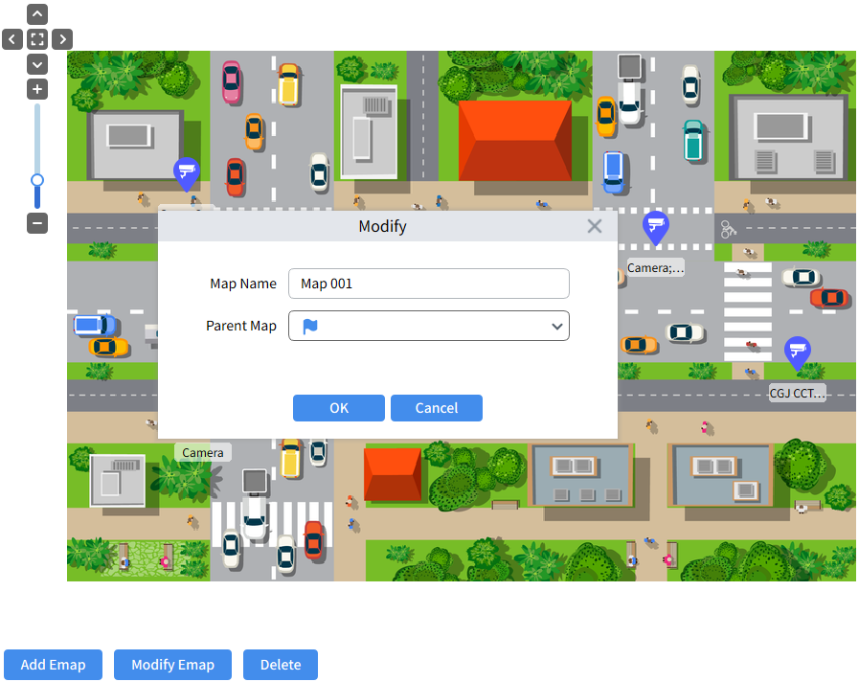

15.2 Deployment of monitoring points
Click“Monitoring Point” option on the left side of the interface to expand the device list , and drag the device channel to the corresponding monitoring point on the map according to the actual installation location of the camera.
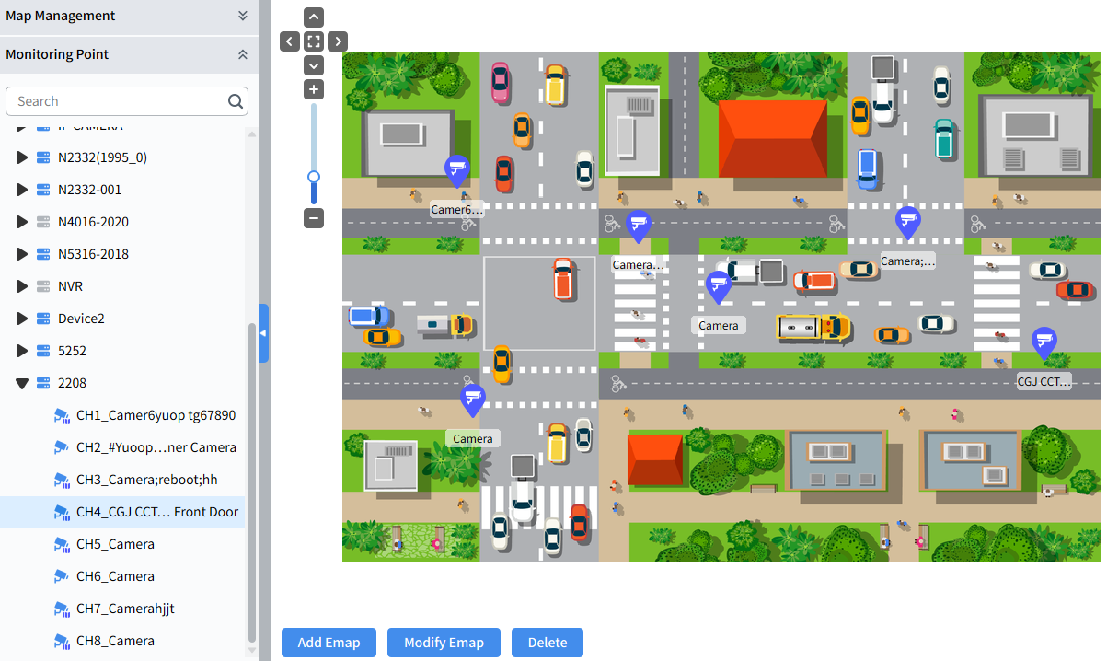

15.3 Modify / delete monitoring points
Select the deployed monitoring point, right-click Edit to enter the modification interface, where you can modify the point name, point logo, name color and name background color, as shown in the figure.
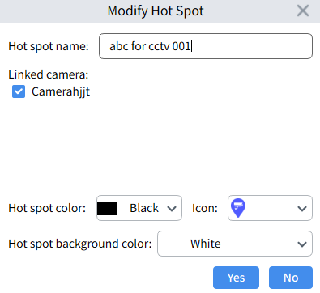
Select the deployed monitoring point, right-click Delete, and select "Yes" in the confirmation menu to delete the monitoring point.

Chapter 16 Map Preview

16.1 Monitoring
Through the electronic map, you can intuitively understand the location of the alarm channel and view the video or alarm status of the channel in real time .
Click Emap Monitoring in the main menu to enter the map preview interface, as shown below picture.
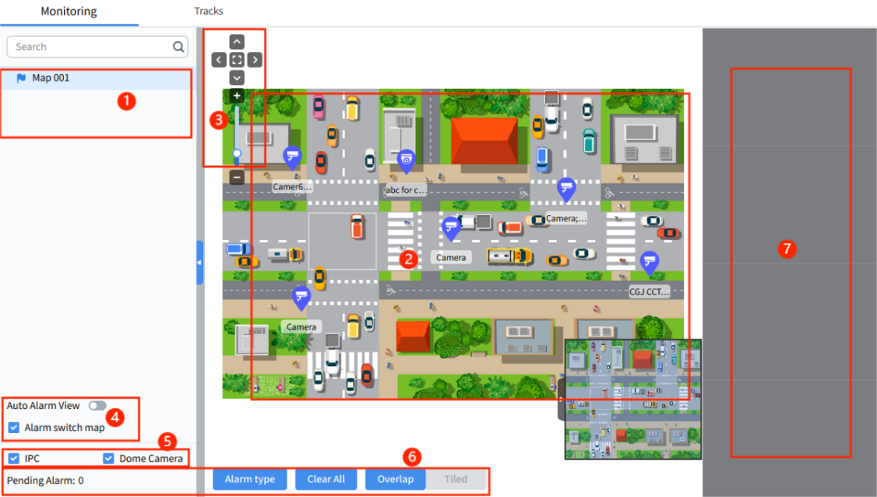
1. Map: Display the added map
2. Map preview: After clicking on the selected map, the map view will be displayed there
3. Map operation area: You can perform operations such as up, down, left, right, and zoom on the selected map
4. When automatic alarm preview is enabled and an alarm is triggered on a device that has been added to the map, the alarm type logo will be displayed on the map, and the real-time image will be automatically played in the preview box on the right, if it is not enabled, it will not be automatically previewed in the window, and only the triggered alarm type logo will be displayed next to the corresponding device on the map.
5. Equipment type: Select the equipment type to be displayed on the map. The selected type will be displayed on the map.
6. Alarm type: You can select the alarm type to be displayed on the map, click 'Clear All' to clear the pending alarms, click “Overlap / Tiled” to change the layout of the preview window to tiled or stacked , as shown in the following figure.
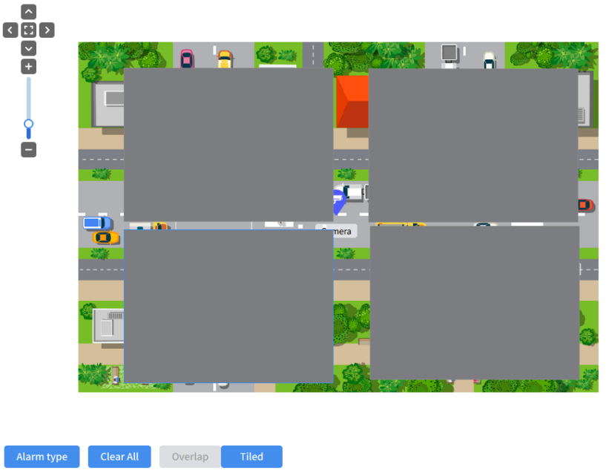
- Alarm preview area: When double-clicking the device or the automatic alarm is checked and an alarm is triggered, the real-time image will be displayed in the preview area on the right, with a maximum of 4 images displayed.

16.2 Track Playback
The camera captures the facial information of the person and records the time when he or she appears in the monitoring area. These face recognition records are played back in chronological order to clearly show the movement trajectory of the retrieval target in the area.
To use this function, you need to confirm that the face recognition function has been enabled on the cameras added to the monitoring area.
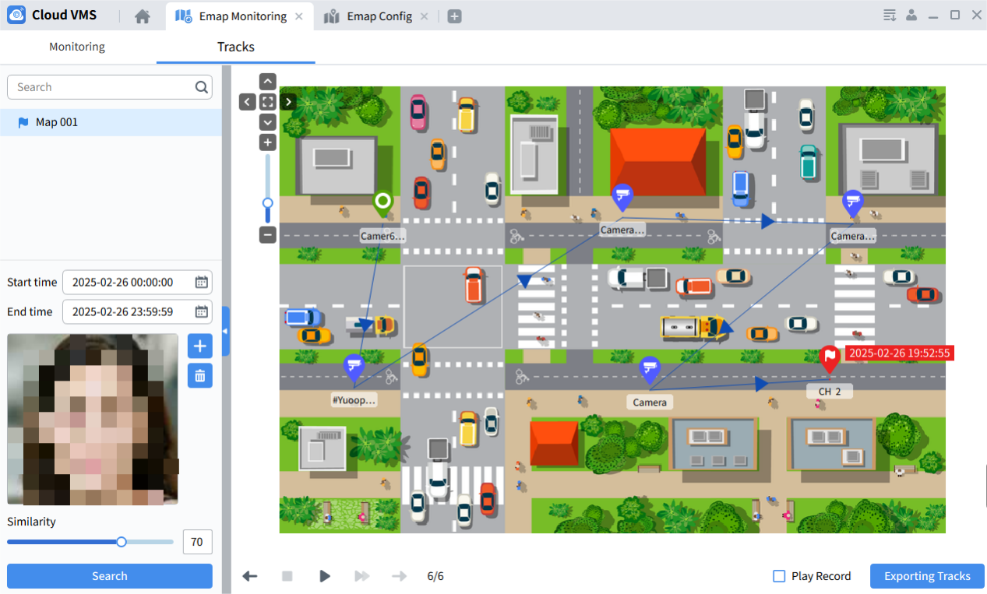
- Set search time period
- Click select the face image of the search target to import. The imported face image will be displayed in the picture box below
- Click delete the imported face image. After deletion, the face image will not be displayed in the image display box.
- Click the search button to display the camera that captured the face on the map, and mark the first capture point and the last capture point .
- Click to play the captured track
- After selecting Play Record at the bottom, click play the captured track and the corresponding recording event of the captured point.
- Click select a local directory to export the face capture information generated by the trajectory

Chapter 17 Account Management
On this page, you can add sub-users and configure permission groups .

17.1 Adding user
Step 1 : Select “Account Management” in the main menu to enter the account management ---user management interface, as shown in the figure.
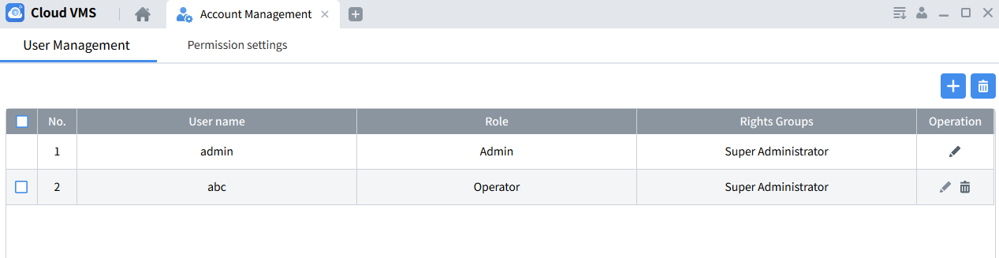 Step 2 : Click in the upper right corner of the interface to open the add user menu, set the user name and password, configure the created permission group, and complete the sub-user configuration, as shown in the figure.
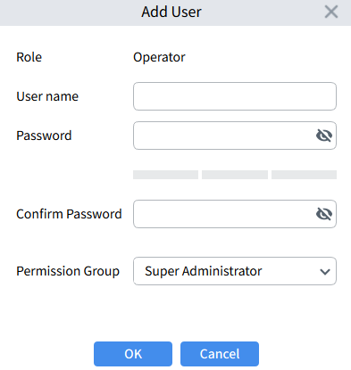
Select the added sub-user and click the button to delete it.
Note: Administrator users cannot be deleted.

17.2 Configure permission groups
Select “Account Management” in the main menu to enter the account management---authority setting interface, as shown in the figure.
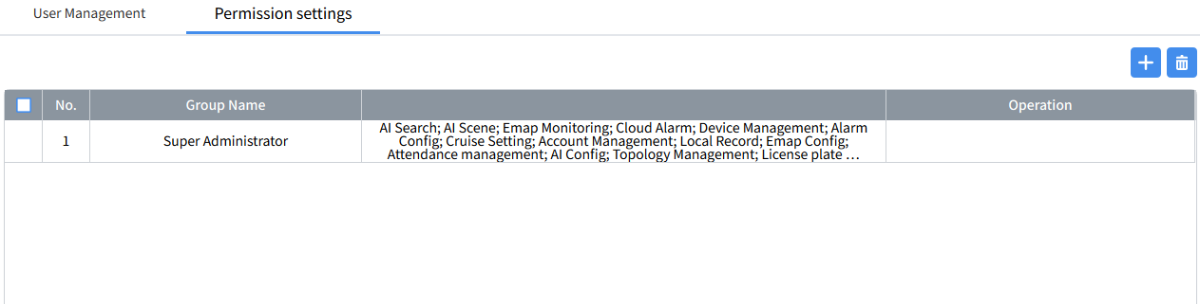
Click on this page to open the permission group configuration menu, set the group name, and the operational permissions of the devices under the group, as shown below picture.
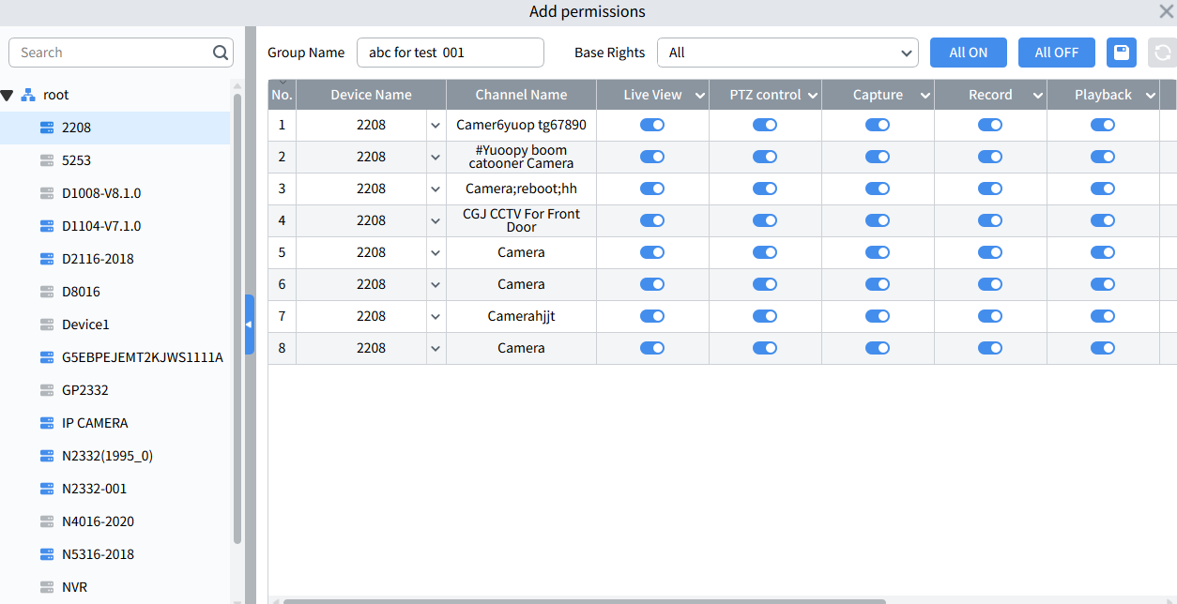

Note: The permission group configuration list does not support the configuration of devices that record to the cloud or devices that are on the cloud.

Chapter 18 Cloud Alarm

18.1 Cloud Alarm
Click “Cloud Alarm” in the main menu to enter the Cloud Alarm--Alarm Message page, as shown in the figure.
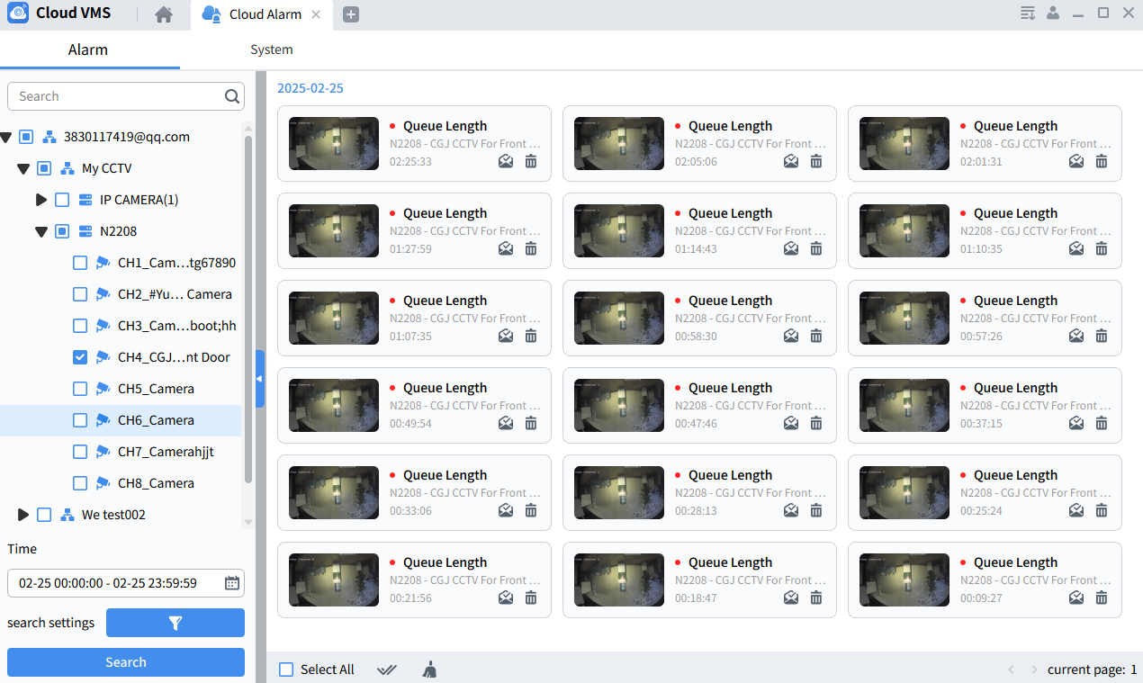

Select an online device in the device list, set the query time period, query message type, and click Search to obtain the alarm message of the selected device from the cloud. Click the message thumbnail to play the message.

Select a single unread message and click read the selected message. Select all unread messages and click read all messages.
Select a single message and click delete the selected message. Select all messages and click delete all selected messages.

18.2 System Messages
Click “Cloud Alarm” in the main menu to enter the Cloud Alarm-System Message page. On this page, you can view group or device sharing information from other accounts, as shown in the figure.
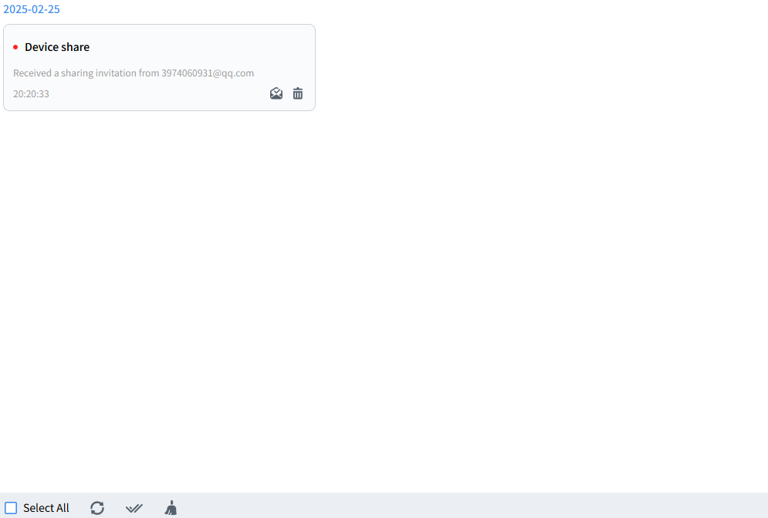
Select a single unread message and click to read the selected message. Select all unread messages and click to read all messages.
Select a single message and click to delete the selected message. Select all messages and click to delete all selected messages.
Note: The cloud alarm function is only available for devices that support cloud services. In normal login mode, you need to log in to the cloud account to use the cloud alarm function, and the device must be connected to the cloud normally.

